Decomposing Navon’s Forest: Dissecting the Reaction Times of Global and Local Processing

by
Daniel J. Lougen

A research paper accepted and approved in partial
fulfillment of the
requirements for the degree of
Master of Science
in Psychology

Committee:
Dr. Paul Dassonville, Chair
Dr. Ulrich Mayr, Member

University of Oregon

Winter 2025

© 2024 Daniel Lougen

ABSTRACT

Daniel J. Lougen

Master of Science in Psychology

Title: Decomposing Navon’s Forest: Dissecting the Reaction Times of Global and Local Processing

Reaction time studies using hierarchical visual stimuli typically demonstrate that global processing is faster than local processing (global precedence effect), and that global interference during a local task has a greater impact than the opposite (global interference effect). Previous examinations of individual differences in these reaction times have sometimes provided evidence that these effects are modulated by various clinical conditions (e.g., autism), but these reports are inconsistent in the literature. This may be because reaction times are a blunt measure of processing speed, since they provide only a sum of the durations of the many different processes that occur between stimulus and response (including afferent transmission, decision, and efferent transmission), and they are prone to distortion due to speed-accuracy tradeoffs. Here, we used a compelled response task (CR) (Stanford et al., 2010) to tease apart the duration of decision processes from that of non-decision processes (the sum of afferent and efferent delays). Participants viewed hierarchical C’s (large C’s made of small c’s, both of which could be open to the right or left in a mirror-reversed fashion) and reported their orientations at either the global or local level (in a blocked design) with right or left button presses. Our analysis demonstrates that decision times captured both precedence and interference effects in visual processing. In contrast, non-decision times were primarily influenced by the interference effect alone. The combined measure representing the sum of decision and non-decision components serves as a valuable comparative tool when examined alongside standard reaction time measurements. In doing so, demonstrating the ability of the CR to provide more precise measures of the durations of the underlying components of a response indicates benefits of its use over typical reaction time measures for examining individual differences in sensorimotor processing.
This thesis contains previously unpublished co-authored material

- Introduction 6
  - Early Hierarchical Perception 6
  - Global Precedence Effect 9
  - Individual Differences 12
  - Limitations of Reaction Time 17
- Research Questions 21
- Methods 22
  - Participants 22
  - Apparatus 23
  - Stimuli 23
  - General Procedure 24
  - Reaction Time Task 25
  - Compelled Response Task 25
- Results 27
  - Reaction Time Task 27
  - Compelled Response Task 31
  - Analysis of Parameters 32
    - Non-Decision Time (T_{Non-Decision}) Analysis 32
    - Decision Time (T_{Decision}) Analysis 34
    - Time to a Fully Informed Response (T_{FIR}) Analysis 35
  - Individual Differences 36
- General Conclusions 38
- Limitations 40
- Future Experiments 40
- Contributions 42
- Appendix 44
- Within Subjects Descriptive Statistics 44
  - Subject Tachometric Curves 47
  - Parameter Comparison Plots 50
    - Across Conditions 50
    - By subject 51
  - Line of Equality Plots 59
- Bibliography 60

Figure 1. Demonstration of the global-local visual hierarchy using images of a dog and a forest. 8
Figure 2. Example of stimuli used by Navon in his 1977 study. 9

Introduction

Early Hierarchical Perception
Early vision sciences were shaped by the debates between structuralists and Gestalt psychologists. The structuralists argued that perception is atomistic, processed from the ground up, while the Gestalt psychologists contended that perception is contextual and holistic. Ultimately, the Gestalt perspective prevailed, leading to an understanding of the principles that guide how we perceptually group objects based on similarities such as shapes and proximity (Kimchi, 1992; Wagemans et al., 2012). This research subsequently led to the concept of perceptual holism, where perception is more than just the individual sum of its components. We can think of this like viewing a mosaic where each tile contributes to the complete image.
Using this wholistic lens for perceptual analysis raised a crucial question: “How is the information processed and in what order?” David Navon (1977) investigated this very question and proposed that perception processes the whole before the parts. He explained that the perceptual system, when divided into the global (the whole) and local (the parts) levels, processes global information before local information. He eloquently summed this up with a metaphor: we process the forest before the trees, where the forest represents the contextual whole and the individual trees represent the details of the scene. One might be inclined to assume that this is indicative of a serial process, where global processing precedes local processing. However, Navon emphasizes that these levels are processed in parallel within a finite resource system, which reflect a continuous and dynamic allocation of resources to process the hierarchy fully (Navon, 1981).
In Figure 1, the global level elements in the red boxes encapsulate broader features, such as the forest and the dog. When viewing the local elements in the blue boxes, we see singular elements like eyes and noses that contribute to a face, as well as individual trees that make up the forest. While the terms "global" and "whole" might seem synonymous at first glance, Navon's research into perceptual processing suggests otherwise. "Global" refers to the overarching, high-level aspects of a stimulus, typically focusing on the larger structure or shape. In contrast, "whole" encompasses both the global and local levels, integrating the overall structure with the finer, detailed components.
To investigate the time course at which local and global information is processed by the brain, Navon (1977) utilized hierarchically nested letters, now referred to as Navon letters. As shown in Figure 2, Navon used the large global letters H and S, which were composed of small H or S letters at the local level. Participants were asked to attend either the global or local level, and decide if they saw an H or S. For example, in Figure 2, participants could be shown any combination of the letters at each level. In a consistent condition, the global letter is made of the same letter at the local level, such as an H made of H’s or an S made of S’s. In the inconsistent condition, the letters would be composed of the other letter, like an H made of S’s or an S made of H’s. For experimental purposes, he also added the letter O to create neutral conditions, with a global O made of local H’s or S’s, or global H’s or S’s made of local O’s.
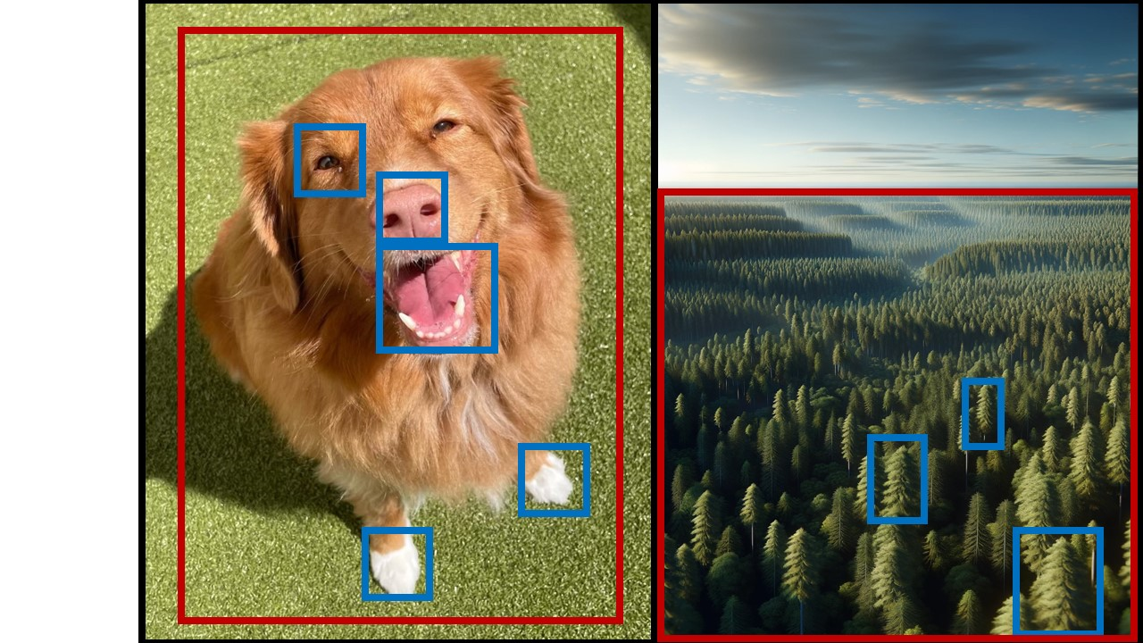
Figure 1. Demonstration of the global-local visual hierarchy using images of a dog and a forest.
The red squares denote global elements (dog's head, forest landscape), while the blue squares highlight local details (dog's eyes, nose, paw; individual trees).
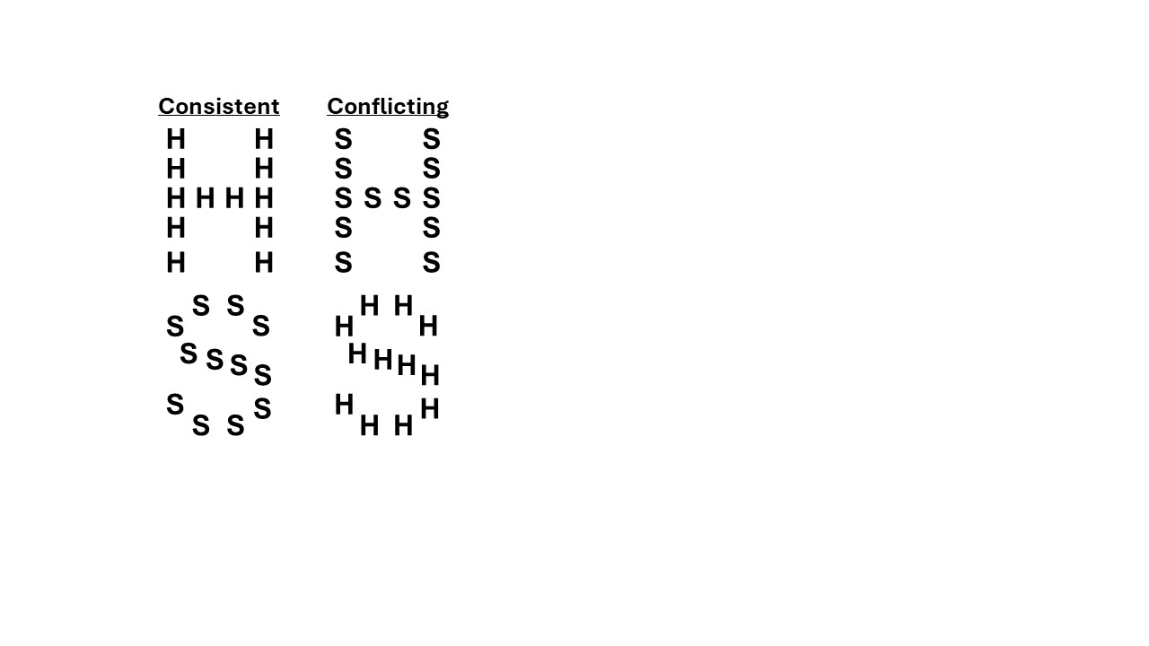
Figure 2. Example of stimuli used by Navon in his 1977 study.
The left column shows the consistent condition, where the global letter (H) is consistent with the local letters (H). The right column shows the conflicting condition, where the global letter (S) differs.

Global Precedence Effect
What Navon was able to extrapolate was that while processed in parallel, information at the global and local levels were not treated equally in the visual system. His analysis of reaction times (RTs) revealed two key effects central to his work: the Global Precedence Effect (GPE) and the Global Interference Effect (GIE). Participants responded more quickly to global features, as demonstrated by the mean RTs for the global conditions—462ms for consistent, 471ms for neutral, and 477ms for conflicting conditions. In contrast, responses to local features were slower for each of these conditions, with mean RTs of 573ms for consistent, 581ms for neutral, and 664ms for conflicting conditions. The presence of the GPE suggests an early visual system bias toward processing global information, as seen by the shorter RTs. This effect is quantified as the difference in mean RTs between the local and global levels, calculated as: GPE = local RT - global RT. In Figure 3 this can be seen as the latency between the bottom line (global-directed) and the top line (local-directed) in each consistency condition. The GPE for the consistent condition shows a 111ms latency when directed locally versus globally, meaning local features take, on average, an extra 111ms to process. This latency gap widens to 187ms in conflicting conditions, indicating that conflicting global features interfere with processing at the local level. The additional time taken for the local response reflects the interference due to irrelevant information contained in the incongruous global figure, as evidenced by the shorter RTs in the local consistent (573ms) versus local conflicting (664ms). The temporal difference, while indicative of a bias, doesn't fully capture the significant degree to which our cognition prioritizes global perception. The magnitude is better captured by comparing the latency added by the unattended level in conflicting conditions. Using this difference of differences (Local interference – Global Interference), we are able capture the GIE, which demonstrates the disruptiveness of conflicting global information compared to conflicting local. In Navon's experiment, this difference revealed a 76ms latency to local responses in the presence of conflicting global information. In Figure 2, this interference occurs when focusing on the local features of the stimulus where, for example, an H is made of S's or an S made of H's. The perceptual bias for the global level attenuates the speed at which local features are processed and thus takes longer to process (Navon, 1977, 1981). The data Navon (1977) collected showed non-significant differences at the global level (p>.05) between conditions. This suggests that global information is prioritized and that any differences in local information has an almost negligible effect on processing. When comparing the conditions at the local level we do see a significant interference effect (p<.01) emerge further emphasizing the global bias. This suggests that despite voluntarily focusing on the elements, the visual system is still affected of the perceptual whole.

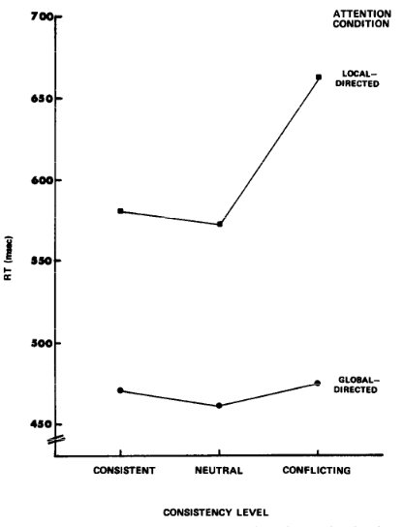
Figure 3. Reaction time plot from Navon (1977) demonstrating global precedence and interference effects.
The consistency level represents if the global and local elements matched. With consistent being matching and conflicting
To illustrate this further consider walking into a room where an orchestra is playing a song. Upon initial hearing, the most salient features that emerge are those of the orchestra as a whole. At the global level, we effortlessly notice the harmony and overall flow of the piece, creating a cohesive sound. However, when attempting to listen to a single (local) instrument, the task becomes harder and requires more focus. Notice the difficulty of each task and the resources that go into accomplishing them: at the global level, it is effortless, while at the local level, you find yourself straining to focus through the noise.
In the decades since Navon's original experiments, the GPE has been robustly replicated using diverse stimuli in multiple cognitive research domains. Where it has been used to observe how hierarchical processing evolves in adolescence (Scherf et al., 2009) and adulthood (Scailquin, 2000; Staudinger et al., 2011a). As well as investigating individual differences in subjects with attention hyper deficit disorder (ADHD, Akerman et al., 2023; Yuan et al., 2024) and autism spectrum disorder (ASD, Baisa et al., 2021; Van der Hallen et al., 2015, 2017), as well as within the domain of religious beliefs (Colzato et al., 2010). However, despite consistent replicability, the GPE is not always present at the same magnitude or even at all. Naturalistic scenes are far more complex than simple Navon letters, containing multiple levels of hierarchy, textures, and gradients, which can confound our measurements. These complexities add further obstacles for identification and signal detection. Studies on non-human animals have shown that both pigeons (Santacà, 2024; Watanabe et al., 2019) and baboons (Deruelle & Fagot, 1997; Fagot et al., 2001) demonstrate a preference for local features. Notably, this local bias, however, is absent in other primates like chimpanzees (Fagot et al., 2001) and macaques (Feltner & Kiorpes, 2010; Santacà, 2024).
It is also important to consider methodological approaches, such as visual angle, when investigating hierarchical figures. This was first demonstrated by Kinchla and Wolfe (1979) in a target detection task utilizing Navon letters. Participants were instructed to search for the target letter as indicated by an audio cue and report if it was present. They manipulated the visual angle of the global figure, with sizes including 4.8°, 6.7°, 8.0°, 10.3 °, or 22.1°. The resulting observations suggest that the GPE is most prominent with sizes between 6° and 9°. But at larger visual angles, the effect reverses creating a local precedence effect. However, Navon and Norman (1983) argued that the effect might instead be due to differences between foveal and peripheral processing. Their task utilized the letters C and O to keep all information in the parafoveal field, avoiding confounding factors such as eccentricity and globality. By keeping eccentricity constant with identical shapes, they found that the GPE was present in both large and small subtended angles, suggesting that the GPE is unlikely to be due to salience at the global level. Furthermore, stimulus composition also plays a role in perceptual bias. For example, Martin (1979) showed that the number of elements could modulate these biases, with a local bias evident when elements are sparse.

Individual Differences
In contemporary research, the GPE serves as a crucial measure for investigating how individual differences influence perception. Evidence suggests that the GPE diminishes with age, indicating a shift in perceptual processing priorities over the lifespan (Müller-Oehring et al., 2007; Scailquin, 2000; Staudinger et al., 2011). Additionally, sex differences in GPE have been shown to be influenced by hemispheric specialization and hormonal variations, leading to distinct perceptual patterns between males and females (Müller-Oehring et al., 2007; Pletzer, 2014). Using Navon figures, it was found that males are faster at identifying global figures, while females tend to use a more local strategy associated with left hemisphere dominance (Razumnikova & Volf, 2010). More recently, Hausinger and Pletzer (2021) discovered that levels of progesterone and testosterone influence the precedence and interference effects. Progesterone, the primary female sex hormone, and testosterone, the primary male sex hormone, both play significant roles in development. Progesterone, in particular, was found to be crucial in predicting precedence and interference effects due to hemispheric asymmetries in males. In contrast, Voyer and MacPherson (2020) found that males were not more efficient at holistic processing than females regarding the precedence effect. Instead, males were better at applying a “piecemeal strategy” using an attentional zoom to focus on local features. Cultural backgrounds also modulate this effect; for example, East Asians, possibly due to collectivistic societal norms, exhibit enhanced global processing compared to their Western counterparts (Carther-Krone & Marotta, 2022; Chua et al., 2022). Similarly, religious affiliations, reflecting collective versus individualistic value systems, have been associated with noticeable differences in global-local processing, suggesting that such perceptual tendencies may also be shaped by the underlying values attributable to religious beliefs (Colzato et al., 2010; Hommel & Colzato, 2010). This makes it clear that our perception is unconsciously influenced by numerous factors of everyday life.
A significant focus has shifted towards investigating differences in local and global processing in clinical populations, as research has pointed toward unique perceptual accounts tied to neurodevelopmental disorders like autism spectrum disorder (ASD) and attention hyper deficit disorder (ADHD). ASD is a multifaceted disorder defined by challenges in social interactions, heightened sensory sensitivity, and a tendency towards repetitive behaviors and restricted interests (American Psychiatric Association, 2013). ADHD is a disorder characterized by persistent patterns of inattention, hyperactivity, and impulsivity that interfere with functioning or development. Individuals with ADHD may struggle with tasks requiring sustained attention, organization, and time management, often appearing forgetful, easily distracted, or disorganized. (American Psychiatric Association, 2013; Faraone et al., 2021). It should be further noted that there is increasing evidence for a notable comorbid relationship between the two. Notably, comorbidity of the two was observed in 32.8% of children with an ASD diagnosis (Canals et al., 2024). A meta-analysis concluded that 40.2% of ASD cases co-presented with ADHD (Rong et al., 2021). Thus, ignoring one while looking at the other may lead to a less thorough analysis.
Research since the 1970s has revealed a propensity for superior visuo-spatial skills in ASD. This has been evidenced through exceptional performance on tasks such as block design and object assembly, as captured by the WAIS and WISC tests (Lockyer & Rutter, 1970; Tymchuk et al., 1977). Pioneering work by Shah and Frith (1983) further illuminated these differences, demonstrating that individuals with ASD exhibit superior target detection in embedded figures tasks compared to neurotypical subjects. Their subsequent research reinforced these findings, showing enhanced spatial reasoning in unsegmented block design tasks among ASD participants, attributed to a reduced cognitive load for extracting local features (Shah & Frith, 1993). Studies pinpointed these superior skills in tasks requiring detailed attention, leading to theories such as Weak Central Coherence (WCC) and Enhanced Perceptual Functioning (EPF), both of which suggest an atypical balance of global and local processing. However, the theories propose that this imbalance is instantiated in different ways – the WCC suggests a difficulty in integrating information into a cohesive whole, a deficit in global processing (Frith, 1989, 2003), whereas EPF posits that individuals with ASD have heightened local processing (Mottron et al., 2006; Mottron & Burack, 2001)
Research on the GPE reveals that individuals with ASD often experience a significant alteration in how they process visual information, showing a local bias or global weakness (Happé & Frith, 2006; Van der Hallen et al., 2015). This unique perceptual orientation, which deviates from the typical precedence given to global features, suggests a fundamental difference in visual processing in ASD. In a meta-analysis investigating the mixed results, Van der Hallen et al. (2015) found that, when accounting for the level attended to, individuals with ASD show a diminished global performance across tasks. When accounting for the order of information presentation, this effect only appeared in conditions where they focused on the global level and had conflicting local information. A subsequent study by the same lab (Van der Hallen et al., 2017) using a divided attention task found both global and local interference effects. Further, the same data contained no indication of significant difference between the control and ASD populations. When investigating the same in a selective attention task they found a typical global precedence effect, with no significant difference in performance between subject samples. More recently, it has been suggested that these discrepant accounts may be a result of differences in experimental methods. When manipulating visual angle and distractor salience, a similar typical global precedence account appeared (Baisa et al., 2021). However, contrasting findings were seen in a figure copying task, where longer gaze times when copying the figure suggested the presence of a global deficit (Seernani et al., 2020). Neufeld et al. (2020) further supports this conclusion in a study of monozygotic twins that found a global processing deficit associated with ASD and ASD traits. Thus, while some studies in the literature have indicated that ASD is associated with differences in global/local processes, others have not. In sum, the question of whether ASD is associated with deficits in global processing, or enhancements in local processing, remains inconclusive.
Perceptual accounts of ADHD have also been inconclusive on the question of a relationship to global/local processing. The disorder is typically associated with hyperactivity and difficulties in focusing on tasks and details, leading to expectations of impaired local processing. A substantial body of research suggests that many of these deficits localize to the right hemisphere (Kalanthroff et al., 2013; Li et al., 2019; Sandson et al., 2000). This finding is neurologically significant because global information is primarily processed within the right hemisphere, indicating hemispheric localized deficits. Key areas implicated in this process include the right parietal lobe, right inferior prefrontal gyrus, and right superior frontal gyrus (Brederoo et al., 2017; A. Flevaris et al., 2010; A. V. Flevaris & Robertson, 2016; Van Kleeck, 1989; Yovel et al., 2001). However, when assessing these hemispheric effects behaviorally using the GPE as a measure, the results reveal an unexpected pattern. Similar to ASD, it has been shown that perceptual accounts of hierarchical processing in ADHD are altered in some capacity. Some studies suggest a lack of a global bias, a reduced global bias, or an enhanced local bias (Karalunas et al., 2014; Song & Hakoda, 2015). An EEG study examining the GPE found significant correlations between early neural responses associated with global processing and deficits in both local and global processing in more severe cases of ADHD (Yuan et al., 2024). In contrast, a previous study using a drawing task in children found no evidence of a local bias or differences from neurotypical controls, attributing any detected differences to an executive functioning deficit in planning (Booth et al., 2003). Thus, like with ASD, the literature provides hints that ADHD is associated with differences in global/local processing, but this assessment is far from definitive.

Limitations of Reaction Time
As mentioned earlier, cognitive sciences rely on RT as a standard measure as it is simple and effective, a testament to the impacts made within in the realm of cognitive neuroscience. RT has a well-established methodological footprint offering a broad-stroke analysis that, despite being robust, encounters limitations via the inclusion of processing mechanisms different from the decision process. Dissecting RT reveals three main components: afferent sensory processing, the decision, and the efferent motor processing (Stanford et al., 2010), with afferent and efferent processes being non-decision components of the task related to the sensation of the stimulus and the physical button-press response, respectively. The inclusion of non-decision processing in the RT only serves to obscure the nuances we are trying to capture, making it clear that more refined analyses require a more refined tool. In the past this would have been approached using a subtractive method, which involves the difference in RT between a simple RT task and Choice RT task (Donders, 1969). With the difference of two being considered the additional amount of time taken to perform the additional cognitive operation. While the method appears intuitive at first the subtractive method is susceptible to three drawbacks. Firstly, it is predicated on the assumption that the cognitive resources used in both tasks are the same. Like the difference between a task involving reacting to a green circle appearing vs a task that asks you to press left for green and right for red. These additional requirements add a need for discriminatory analysis and working memory to map answers accurately to the keys. Secondly, it also assumes that processing terminates with the initiation of the motor action. Thirdly, it is subject to speed-accuracy tradeoffs that come with differences in task needs (Stanford et al., 2010). Taken together, these assumptions alone suggest that this method is largely unsatisfactory and suffers similar blunt measure issues.
Stanford et al.'s (2010) critique of the subtraction method in RT studies elucidates those limitations, prompting the development of the Compelled Response (CR) paradigm as an innovative approach to better quantify the decision process. This method addresses critical issues by allowing for a nuanced dissection of RTs into components of decision and non-decision time. In the CR task, the participant is required to submit their response within a sub-1s response window, with the beginning of the response window marked by a go cue. However, the onset of the stimulus to which the participant must respond is not necessarily presented immediately, but is instead presented after a pseudo-random delay from the start of the response window. If the stimulus is presented early in the response window, the participant will have sufficient time to process the stimulus and initiate a fully-informed response (with a high level of accuracy) before the response window expires. At the other extreme, a delayed stimulus may leave insufficient time to process the stimulus, resulting in a response that is merely a guess, with a 50% chance of being accurate.
By compelling the participant to respond within the duration of the response window, in spite of the delays in stimulus onset, the CR task cuts short the stimulus processing time available on any given trial, allowing for an assessment of the relationship between processing time and accuracy. A schematic of the expected relationship, a form of Stanford et al.’s (2010) tachometric curve, can be seen in Figure 4, with a processing time of 0ms indicating a trial whose response was simultaneous with the stimulus onset. With processing times below a certain limit (depicted here as 215ms), there is not enough time for stimulus information to be considered and provide guidance to the eventual response – hence, accuracy is at chance. Processing times slightly greater than 215ms would allow the decision process to begin, but this process would be cut short, with only a partial effect of the stimulus information guiding the response, allowing a performance that is slightly greater than chance. With even greater processing times, more of the decision process would be completed, allowing accuracy to increase exponentially to a plateau with high (90–100%) accuracy.
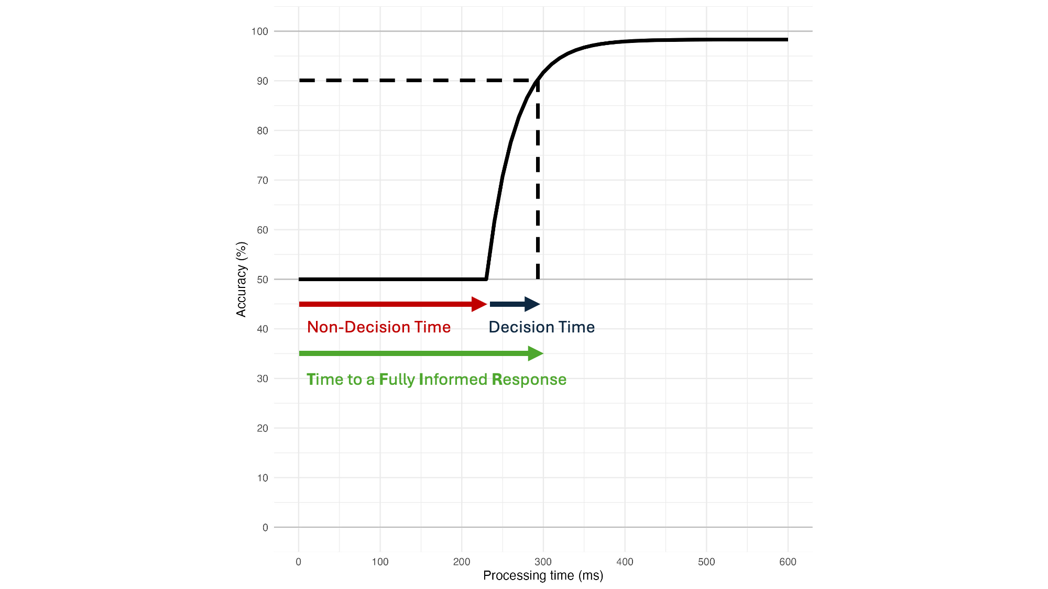
Figure 4. Tachometric Curve
The curve shows the non-decision time (blue arrow) demarking the processing times at which performance is at chance (50%), ending with an inflection point. At which point, processing begins, and the resulting exponential performance denote decision time (red). The sum of those parameters yields minimum informed response time (green) indicating the minimum duration needed to process a stimulus.

The tachometric curve in Figure 4 thus allows for a temporal assessment of separate components of the participant’s sensorimotor response. In particular, the duration at which performance is at chance (215ms, labelled T_{Non-Decision}, in the schematic of Figure 4) would reflect the combined durations of afferent and efferent processing times, with no impact of any decision processing. The duration of the decision itself (labelled T_{Decision} in Figure 4) would begin at the inflection point where accuracy first deviates away from chance performance, and lasts until the plateau is reached (defined here by the time at which accuracy reaches 90%, at a processing time of 300 ms). Thus, the duration of the decision in this example is 300ms – 215ms = 85ms. The sum of T_{Non-Decision} and T_{Decision} can be thought of as the minimum amount of processing time that will allow for a fully informed response to be made (which we will refer to as the time to a fully informed response, or T_{FIR}).
The CR paradigm, therefore, represents an advancement in cognitive neuroscience. By distinguishing between the various stages of the RT, Stanford et al. (2010) have created a tool capable of precisely isolating and quantifying the decision and non-decision components of the RT within attention and decision-making studies. This approach not only resolves some of the shortcomings of Donder’s subtraction method but also provides a foundation for future investigations into the temporal dimensions of cognitive processing, and a more refined comparison of the individual differences of global/local processes and an eventual assessment of differences in processing within clinical populations (e.g., autistic versus neurotypical populations).

Research Questions
The primary goal of this work is to ultimately provide a measure that isolates decision and non-decision components of the RTs in tasks involving global and local processing. These measures offer an opportunity to quantify decision-making tasks more cleanly without interference from non-decision processes. Our questions are as follows:
- Can Stanford et al’s (2010) compelled response task provide us with isolated measures of decision and non-decision times in a Navon task?
- Can the isolated components allow us to better identify individual differences otherwise obscured by reaction time?
In doing so, we expect to demonstrate the feasibility of reducing RT to decision and non-decision times in meaningful way. Additionally, we want to demonstrate that these reduced measures can capture individual differences obscured by RT. In doing so, we will demonstrate the efficacy of the CR paradigm (Stanford et al., 2010).

Methods

Participants
The study was approved by the Institutional Review Board at the University of Oregon. All participants provided informed written consent before taking part in the study. Our cohort consisted of 23 individuals, of which 13 were female, with an average age of 22.48 years (ranging from 18 to 35 years). Criteria for inclusion required participants to have normal or corrected-to-normal vision, and all were recruited from the University of Oregon community. Participants ran seven 1-hour sessions, with compensation structured to increase with each hour spent on the study, starting at $10.00 per hour for the initial session. Each subsequent hour of participation saw an increase of $1.00 per hour, capping at $16.00 per hour for the final session. In instances where technical difficulties, such as computer crashes, necessitated additional time, participants were compensated above the $16.00 per hour rate to account for the extra time spent. Technical issues with the PsychoPy program resulted in data loss for 2 participants, requiring the re-collection of data for the affected sessions. Attrition among the participants resulted in 7 participants not completing the seven sessions – their data were excluded from the final analyses. Another 2 participants failed to reach a threshold performance level of 90% correct across all RT sessions, and their data were also excluded from the final analyses.

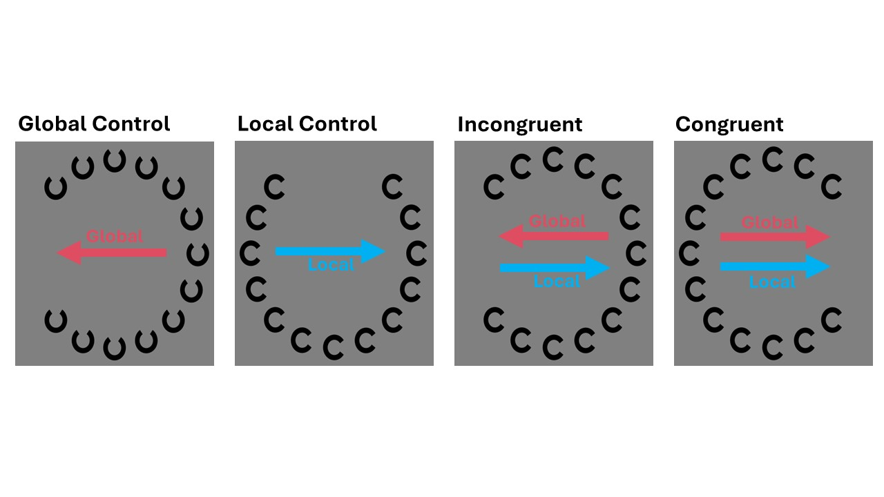Figure 5. Experimental Stimulus
The hierarchical figures represents a subset of the different condition combination presented during the experiment. Participants were instructed to press one of two keys (“f” or “j”) on a keyboard to indicate the orientation of the Cs (that is, the side with the opening) at the attended level for that run The red arrows (unseen by the participants) represent the key press (right or left) appropriate for a global level response guided by the large C. The blue arrows represent the key press appropriate for a local level response guided by the smaller Cs. The first two figures are the controls for each level; in a global task the local Cs were oriented vertically, whereas in a local task the global C was vertically oriented. In the congruent condition the Cs at the global and local levels pointed in the same direction; in the incongruent condition, the C’s at the two levels pointed in opposite directions..

Apparatus
The experiment was completed in an isolated room on a Mac mini 2020 (M1 processor, 8GB memory, Ventura 13.4 OS). Stimuli were displayed on a 24-inch Zowie XL LCD monitor (1024 X 576 resolution, 120hz refresh rate). Participants were seated with their heads placed on a chin and forehead rest positioned 22.5-inches from center of the screen. Lastly, the task was coded and executed using PsychoPy v2022.2.1.

Stimuli
Hierarchically structured Navon letters were created to place both global and local elements in the perifoveal field, ensuring that information at both the local and global levels were equidistant from the fovea. Each stimulus consisted of a large C formed by smaller Cs (see Figure 5), which varied the opening in vertical or horizontal orientation according to the experimental condition. Participants were instructed to attend to either the large C (global level) or the smaller Cs (local level) and respond based on the left/right orientation of the C's opening (see Procedures below). Conditions included congruent (matching orientations) and incongruent (opposing orientations) stimuli. Control stimuli were also presented: during global-level control trials, the small Cs were oriented vertically, and in local-level control trials, the large C was oriented vertically, thus were neither congruent nor incongruent within the participant’s task of reporting the left/right orientation of the attended level.

General Procedure
Participants were asked to complete seven sessions in total: one RT session and six CR sessions. Each session contained eight experiment blocks, with each block comprised of at least 150 trials (see below). Each block of trials required the participant to attend either the global or local level of the Navon figure, with the first block always requiring attention to the global level and then alternating between the local and global levels after that. Prior to starting the first session (an RT session) and the second session (the initial CR session), participants were provided a practice block of trials to learn task requirements, with enough trials (ranging from 20 to 50) for the participant to become comfortable with the task. Within each session, short breaks were provided between blocks, and a longer break was provided after the 4th block. In addition, on any given trial, participants could choose not to respond at all if they felt themselves distracted from the task – after a delay of two seconds with no response, the program went into a break routine that allowed the participant to refocus their attention on the task before beginning again by pressing any key. The trials that received no response in this way were replayed later in the experiment.

Reaction Time Task
The first session was an RT decision task, in which the participant was asked to respond to the orientation of the Navon figure at the attended level using the ‘f’ or ‘j’ key to indicate the orientation (left or right, respectively) of the opening in the large C (global level) or small C’s (local level). Each trial began with a fixation point, followed by a click and the appearance of the stimulus (centered around and replacing the fixation point), with the orientation of the C (or C’s) at the attended level chosen randomly and the orientation of the C (or C’s) at the unattended level pseudo-randomly oriented in a congruent, incongruent or control direction (with equal numbers of each in each block). The participants were instructed to answer, “as quickly and as accurately as possible”.
Before analyzing the RT data, reaction times were filtered for outliers that were ±3 SD from the median. Mean RTs were then compared across conditions, to quantify any precedence and interference effects.

Compelled Response Task
After completion of the RT session, subsequent sessions tested the participant’s performance in a CR task, which leveraged the same basic set up as the RT task. CR trials (Figure 6) differed from the RT trials in that the participant was required to respond within a 700ms temporal response window (the CR window, which began with the offset of the fixation point and whose duration was defined by a series of fours clicks presented 0ms, 233.3ms, 466.6ms, and 700ms from fixation offset). In addition, the Navon stimulus was presented with a variable delay (0m, 60ms, 133ms, 200ms, 267ms, 333ms, 400ms, and 467ms) after the onset of the CR window, which allowed the participant a variable amount of time to process the stimulus before needing to respond by the end of the CR window. We incentivized our participants to answer during the response window via a points system: 2 points for correct responses that occurred during the CR window, 0 points for incorrect responses that occurred during the CR window, and –1 points, paired with a an audible warning (siren sound), for responding after the CR window ended.
To characterize the relationship between PT and accuracy, we fit a tachometric curve (Stanford et al., 2010) to the data for each participant, separately for each task and congruency condition. This curve provides a method of quantifying the time course of the decision process, specifically allowing a calculation of the durations of the decision and nondecision components of the task. The curve itself is calculated using a modified exponential function that assumes that performance will be at chance with very short PTs, followed by an increase in accuracy that exponentially approaches an asymptote level of good performance with longer PTs:
$$For PT≤T_{Non-Decision}, f(Acc)=0.5;$$
$$For PT>T_{Non-Decision}, f(Acc)=0.5+\left({Acc}_{meanRT}-0.5\right)*(1-\exp\left(\frac{-\left(PT-T_{Non-Decision}\right)}{Tau}\right)$$
Where f(Acc) is the tachometric curve’s model time course of accuracy, PT is the processing time for individual trials, T_{Non-Decision} is the non-decision time (sum of the afferent and efferent delays, depicted here as the processing time at which accuracy begins to deviate from chance), and Tau is the time constant of the exponential curve. Since the proportion of correct trials in the RT data was rarely 1.0, it could not be assumed that the plateau accuracy in the CR task would be 1.0; instead, we assumed that the plateau accuracy in the different combinations of Task (global, local) and Congruency (congruent, control, incongruent) of CR tasks would equal the average accuracy of that same trial type in the RT task (Acc_{meanRT}). To determine the values of T_{Non-Decision} and Tau, we used the ‘optim’ function from the ‘Stats’ package in R (R Core Team, 2013) to iteratively fit the tachometric function to the data. To avoid local minima, this fit procedure was completed using random starting values 1000 times for each trial condition, keeping the resulting set of parameters that led to the lowest sum of squared errors. Although T_{Non-Decision} provides a direct measure of the combined afferent and efferent delays, Tau (which represents the time required for the exponential rise in accuracy to move from chance to 75%) must be multiplied by a factor of 1.61 to determine the threshold at which accuracy surpasses 90%; therefore, T_{Decision} = Tau * 1.61. T_{FIR} (the time to a fully informed response, or the minimum processing time required to make a response with an accuracy greater than 90%) is therefore the sum of the T_{Non-Decision and} T_{Decision}.

Results

Reaction Time Task
The RT task was designed to capture mean RT for each trial type within participants (Table 1) and to quantify the GPE and GIE, allowing for comparisons with traditional global-local processing effects found in the literature. Broadly, the data aligns with Navon’s (1977) findings, demonstrating faster reaction times (RTs) for global tasks compared to local tasks, and a larger interference from extraneous global information in a local task than vice-versa (Figure 8A).
To further investigate the effects of task type and congruency on mean RT, a two-way ANOVA (Task × Congruency) was performed. Results showed a significant main effect of Task, F(1,22)=123.18, p<0.001, ηp²=0.85, 95% CI [0.71, 0.91], with faster RT in the globally-directed task compared to the locally-directed task. This main effect of Task explained a substantial portion of the variance in mean RT. A significant main effect of Congruency was also observed, F(2,44)=28.99, p<0.001, ηp²=0.57, 95% CI [0.36, 0.70]. RT differed across congruency conditions, with congruent trials producing faster RTs compared to both control and incongruent trials, indicating that congruency influences RT independently of task type. Moreover, a significant Task × Congruency interaction was found, F(2,44)=8.36, p=0.0008, ηp²=0.28, 95% CI [0.06, 0.46]. This interaction, in tandem with main effects, suggests that Task type is the primary driver of differences in RT, with Congruency effects modulated by whether participants are attending to global or local information. Specifically, the impact of Congruency is more pronounced within local tasks than global tasks, indicating that task demands play a critical role in how congruency influences response times.

For a more direct comparison to the experimental data, a two-way ANOVA (Task × Congruency) was performed with participants who completed the compelled response task. Results showed a significant main effect of Task, F(1, 13) = 105.74, p < .0001, ηp² = 0.89, 95% CI [0.73, 0.94], with reaction times differing significantly between task conditions. A significant main effect of Congruency was also observed, F(2, 26) = 19.99, p < .0001, ηp² = 0.61, 95% CI [0.33, 0.75], indicating that response times varied across congruency conditions. The Task × Congruency interaction approached significance, F(2, 26) = 2.88, p = .074, ηp² = 0.18, 95% CI [0.00, 0.41].

Table 1
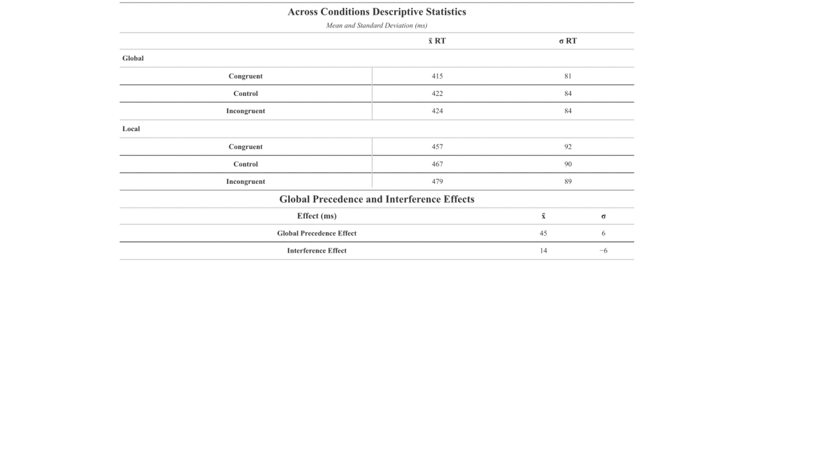
Traditionally these RT differences are more specifically quantified through the measures of GPE and GIE. The magnitude of the GPE is typically assessed through a direct comparison of the RTs in the control conditions, to avoid the possible confounds of congruent and incongruent information. It is calculated as follows:
$$GPE = Local control RT - Global control RT$$
In the present study, responses guided by local information were, on average, 45 ms slower than those guided by global information, and this difference was statistically significant, as assessed with a Welch’s t-test (t(43.88) = -2.58, p = 0.0135). The effect size for this difference was Cohen’s d = -0.78 (95% CI: [-1.39, -0.16], suggesting that the observed difference in reaction times confirms the strong presence of a GPE in our RT task.
The GIE is typically quantified in the literature as a difference of differences, defined as:
$$GIE= \left(Local incongruent RT - Local congruent RT\right)-\left(Global incongruent RT - Global congruent RT\right)$$
In the current study, the first part of the equation represents the impact of extraneous global information on RT when the task requires attending to local information, with the global information speeding RTs by 10 ms (STATS – is the benefit alone significant?) when it is congruent with the local information, or slowing RTs by 12 ms (STATS – is the benefit alone significant?) when it is incongruent, resulting in a difference of 23 ms in our data. The second part of the equation represents the impact of extraneous local information on RT when the task requires attending to global information, with the local information speeding RTs by 7 ms (STATS – is the benefit alone significant?) when it is congruent with the local information, or slowing RTs by 2 ms (STATS – is the cost alone significant?) when it is incongruent, resulting in a difference of 9 ms. The 14 ms difference between these values, the GIE, is statistically significant, as assessed with a Welch’s t-test t(112.61) = -5.45, p < 0.000001, with an effect size of Cohen’s d = -1.03 (95% CI: [-1.42, -0.63]).
The GPE and GIE measured in the present study are smaller than those reported by Navon (1977), who found a GPE of 110 ms and GIE of 76 ms, they were nonetheless significant. This discrepancy may be attributable to methodological differences, such as the letters used, stimulus size or retinal eccentricity.

Compelled Response Task
Overall, our primary goal is to evaluate the CR paradigm (Stanford et al., 2010) as a viable method for separately quantifying the decision and non-decision processes of RT. Within each participant, we derived (as in Figure 4) the tachometric curve for each trial type, quantifying the best-fit T_{Non-Decision} (the sum of the afferent and efferent delays, and depicted here as the processing time at the inflection point where accuracy rates first deviate from chance) and Tau (the time constant that quantifies the rate of change in the exponential rise in accuracy). These values were then used to calculate T_{Decision} (Tau *1.61, the rise time of the tachometric curve, measured from the onset of the rise above chance performance until performance reached 90% of the plateau in accuracy) and T_{FIR} (T_{Non-Decision} + T_{Decision}, the processing time required for a fully informed response). Figure 7 shows tachometric curves for the individual trial types, created with the mean best-fit parameters from all subjects, superimposed on the data from all subjects (with PT segregated into 15ms bins, and data point size depicting the number of trials included in each bin). Table 2 and Figure 8 depict the values for the best-fit parameters averaged across participants. Figure 7A allows a comparison of the global control (red) and global control (blue) trials, with the mean T_{Non-Decision} slightly longer in the local task than in the global task, whereas the mean T_{Decision} is dramatically longer in the local task (detailed statistics will be presented in the next section). In Figure 7B, it can be seen that although the T_{Non-Decision} and T_{Non-Decision} times are roughly similar in the global congruent (dark red), global incongruent (pink) and local congruent (blue) trials, both of these durations are extended for the local incongruent (light blue).
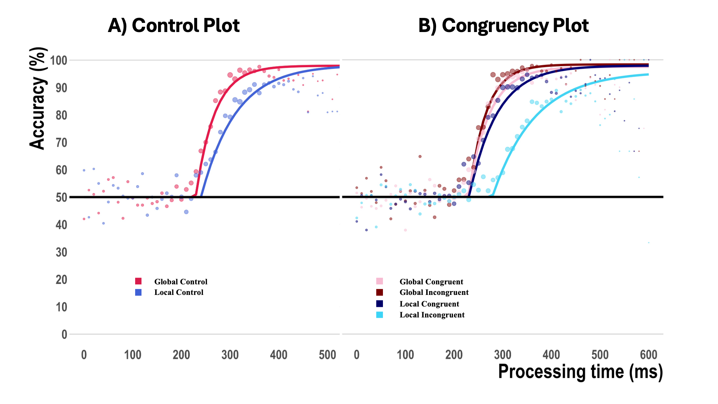
Figure 7. Tachometric Curves and Observed Data Across Subjects
A) Average tachometric curves for the global and local control conditions, using Start, Tau and Acc_{meanRT} parameters averaged across participants. Data point sizes represent number of trials contained within each 15 ms bin. B) Average tachometric curves corresponding to the global congruent, global incongruent, local congruent, and local incongruent conditions.

Analysis of Parameters
A repeated-measures ANOVA was conducted to examine the main effects of Task and Congruency, as well as their interaction, on each parameter.

Non-Decision Time (T_{Non-Decision}) Analysis
The analysis of T_{Non-Decision} (Figure 8B) revealed a statistically significant main effect of Task, F(1,13)=10.54 , p=.006, partial η²=0.45, 95% CI [0.06,0.70], indicating that non-decision times differed significantly between global and local tasks. There was also a significant main effect of Congruency, F(2,26)=7.44, p=.003, partial η²=0.36, 95% CI [0.07,0.58], suggesting that non-decision times varied across the congruent, control, and incongruent conditions. Additionally, a significant Task × Congruency interaction was found, F(2,26)=10.18, p<.001, partial η²=0.44, 95% CI [0.13,0.63], indicating that the effect of Congruency on non-decision time was moderated by the task type.
Another aim of this investigation was to quantify the precedence and interference effects within the parameters of the tachometric curve (T_{Non-Decision}, T_{Decision}, and T_{FIR}), and to provide a comparison with the same effects measured in the RT task, where both the GPE and GIE were found to be significant (45 ms and 14 ms, respectively; Figure 8A).
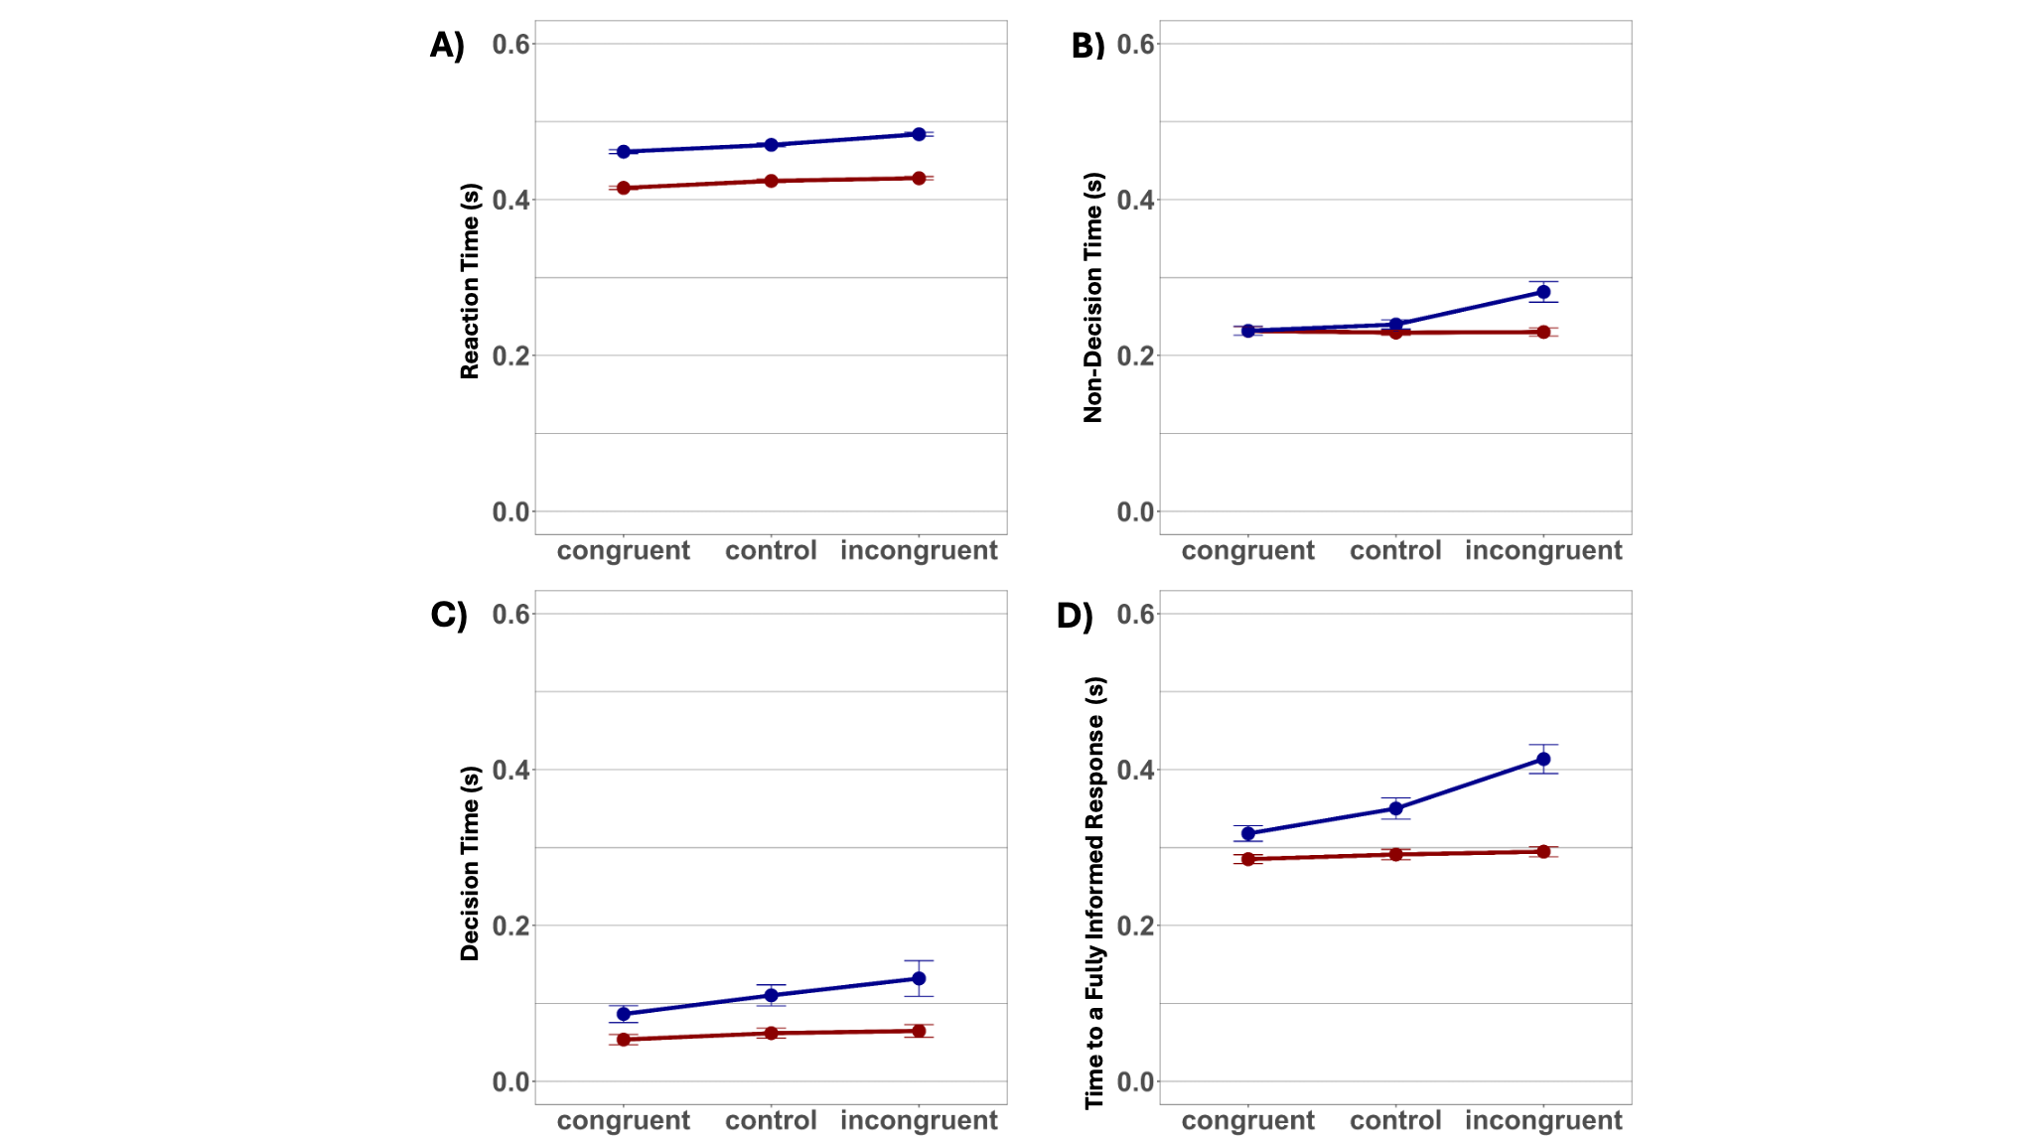
Figure 8. Mean Measure Comparison Between Subjects
To test for the presence of a GPE within the non-decision time, T_{Non-Decision} in the global control task was subtracted from that of the local control task for each participant. The mean GPE across participants was found to be 11 ms, but a Welch’s t test found the effect to be non-significant, t(20.39)=−1.63, p=.1195, d=−0.72, 95% CI [−1.61,0.18]. In contrast, the effect of congruency on T_{Non-Decision} in the local task was substantially greater than in the global task, yielding a significant GIE of 48 ms, t(57.06) = −2.98, p=.0043, d=−0.79, 95% CI [−1.32,−0.25]. These results indicate that although the efferent and afferent delays of sensorimotor processing in the CR task do not differ between the local and global tasks, the impact of irrelevant global information in a local task is greater than that of irrelevant local information in a global task. This effect is particularly evident in the marked increase in non-decision time in the local incongruent condition, as illustrated in Figure 8B.
Table 2
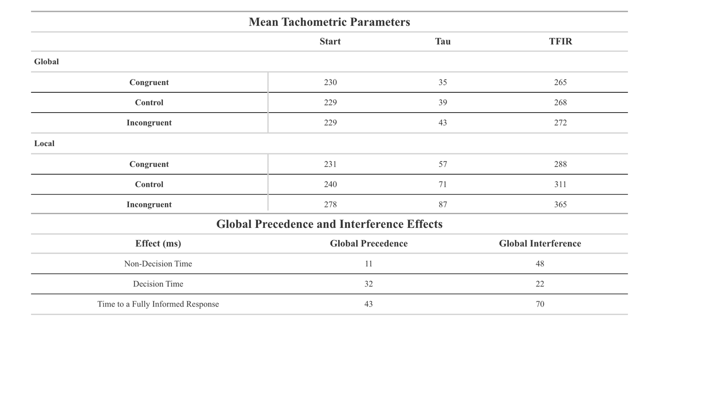

Decision Time (T_{Decision}) Analysis
An analysis of T_{Decision} (Figure 8C) revealed a statistically significant main effect of Task, F(1,13)=20.98, p=.0005, partial η²=0.62, 95% CI [0.22,0.80], indicating that decision times differed significantly between the global and local task conditions. There was also a significant main effect of Congruency, F(2,26)=6.86 , p=.004, partial η²=0.35, 95% CI [0.05,0.56], suggesting that decision times varied across the congruent, control, and incongruent conditions. The Task × Congruency interaction, however, was not statistically significant, F(2,26)=2.56, p=.097, partial η²=0.16, 95% CI [0.00,0.40], indicating that while there was some interference caused by the unattended elements in both tasks, the magnitude of the interference was independent of the attended level.
A more direct quantification of the GPE on decision time was made by directly comparing T_{Decision} in the local control and global control tasks. Across participants, decision times were found to be 32 ms longer in the local control task than in the global control, t(18.61) = -3.10, p = .00599, d = -1.44, 95% CI [-2.44, -0.40], indicating a robust GPE. Similarly, a pronounced GIE effect of 22 ms was observed (t(54.89) = -4.62, p = .00002, d = -1.25, 95% CI [-1.82, -0.66]), with a greater impact of the irrelevant global information on a local task than vice-versa.

Time to a Fully Informed Response (T_{FIR}) Analysis
An analysis of T_{FIR} (Figure 8D) yielded a statistically significant main effect of Task, F(1,13)=69.09, p<.001, partial η²=0.84, 95% CI [0.61,0.92], indicating that the time to form a fully informed response (the sum of the non-decision and decision times) differed significantly between the global and local levels. There was also a significant main effect of Congruency, F(2,26)=40.21, p<.001, partial η²=0.76, 95% [0.56,0.85], suggesting that T_{FIR} varied across congruent, control, and incongruent conditions. Additionally, a significant Task × Congruency interaction was found, F(2,26)=31.37, p<.001, partial η²=0.71, 95% CI [0.48,0.82], indicating that the effect of Congruency on T_{FIR} was moderated by the task type.
The analysis of T_{FIR} revealed significant global precedence and interference effects. The robust GPE was evidenced by the finding that the local control trials took 43 ms longer to reach an accuracy of 90% compared to the global control trials, t(19.18) = -3.83, p = .00112, d = -1.44, 95% CI [-2.44, -0.40]. Similarly, a substantial GIE was observed, with the impact of irrelevant global information on a local task 70 ms than the reverse, t(50.94) = -6.32, p < .00000007, d = -1.77, 95% CI [-2.41, -1.12]. These findings demonstrate that the processing time required to allow for a fully informed response is influenced by both precedence and interference effects.

Individual Differences
The overall goal of the study was to determine whether the CR task provides a robust methodology for assessing the time course of global and local processing, and for quantifying individual differences in these measures, addressing areas that have traditionally produced inconclusive results with RT measures. By analyzing parameters within subjects, it becomes clear that individuals are affected differently by precedence and interference effects.

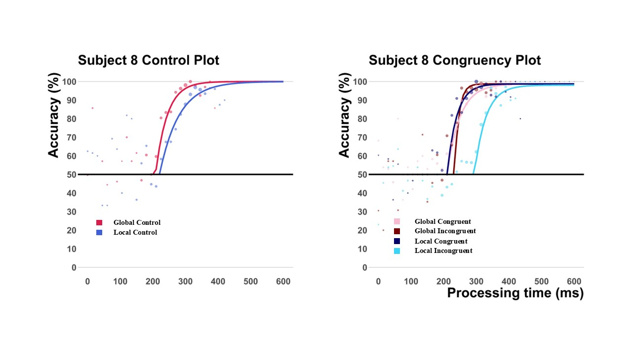

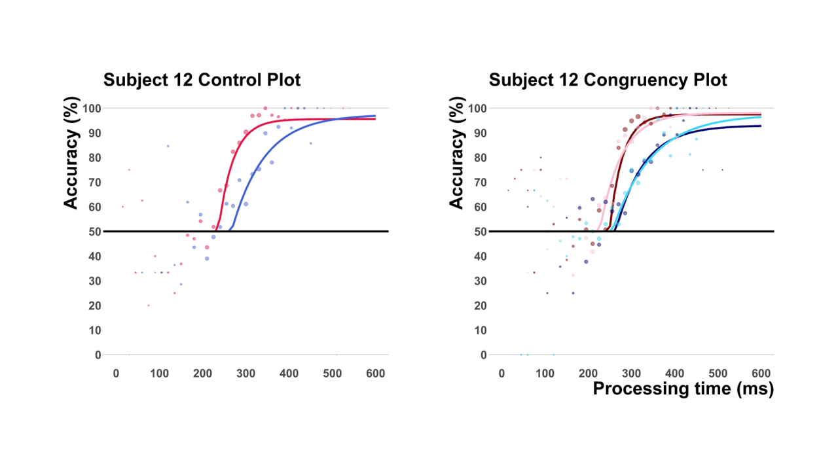
Figure 8 Individual Subjects Tachometric Curves
For example, an analysis of Subject 8's control plot reveals the precedence effect through differences in the starting points and slopes of the curves in Figure 8. The GPE is represented by the difference in non-decision times, with the local curve starting later than the global curve. It is also evident in the curve slope, where the decision time is longer, as indicated by the flatter slope. In the congruency plot, the global conditions and the local congruent condition cluster closely together due to the facilitative effect of global congruence on processing, while the local incongruent condition shows considerable latency. The differences primarily emerge in non-decision times, as the curves share similar slopes, indicating comparable decision times. This pattern suggests that the variance is predominantly attributed to when stimulus processing begins, driven by conflicting stimuli rather than the attended level.
In contrast, Subject 12's control plot in Figure 8 demonstrates the precedence effect in both decision and non-decision times. The subject exhibits a greater latency in decision times compared to Subject 8, along with a much longer decision-time slope. This indicates that the precedence effect influences both parameters. In the congruency plot, a much stronger task-level effect influences Subject 12's decision times, as the curves for the local condition flatten considerably. Interestingly, the interference effect manifests similarly in non-decision time but not in decision times. This suggests that the precedence effect primarily influences how long it takes this individual to process stimuli.
If RT were used alone, both precedence and interference effects would be observed, but their contributions would be limited to confirming their presence. By analyzing the parameters and curves, however, we can derive more detailed insights beyond the mere identification of these effects. This approach enables us to attribute differences in RT more precisely by disentangling them into decision and non-decision components, thereby providing a deeper and more nuanced understanding of the global precedence hypothesis.
In the case of each subject, we see that references to the mean RT do yield useful information. But do not deliver on the quantity or quality of data that one captures with CR derived parameters. Within each participant’s RT we detected precedence effects well and interference to a lesser degree. When using the parameters we see that the precedence and interference effects are detected and show varying degrees of those effects unique to that subject. Demonstrating that individual differences are capable of obscuring present effects in mean RT. In the case of ASD, we can better approach prior inconclusive findings with a new light. Where, for example, we might find non-decision times reflect a deficit and the presence of a local bias in decision time obscures it. Understanding the structural components of our metrics is imperative if we want to examine the complexity of intra-individual differences.

General Conclusions
Since its inception in experimental psychology, RT has served as a gold standard measure across various paradigms, showcasing versatility and simplicity that have allowed it to remain relevant in modern science. However, like any measure, RT has its limitations, particularly its tendency to obscure observed relationships by conflating decision and non-decision processes. Utilizing the CR paradigm designed by Stanford et al. (2010) to investigate the global precedence effect, we demonstrate that RT can be decomposed into its constituent components using variable gaps, enabling us to identify the distinct time courses of non-decision and decision processes. Through the use of the psychometric function, we quantified individual variability in decision parameters across task conditions (global and local) and congruency conditions (congruent, control, incongruent). Similar to RT, we detected both precedence and interference effects consistent with Navon’s work, but with greater variability in the measures of non-decision and decision time.

Overall, the parameters demonstrate a superior ability to mean RT in their effectiveness at capturing precedence and interference effects. Non-decision times, for example, emphasize differences that stem from conflicting information rather than the attended level, offering deeper insights into the underlying cognitive mechanisms. However, it does not capture the extent of the precedence effect in the same way decision time does. Where decision time captures both a global precedence and interference effects. In contrasting the different parameters, we are able to see that the global precedence effect is a processing related component. Whereas the global interference effect manifests in when we begin and how it takes for us to process the stimulus.
This level of precision is particularly critical when examining individual differences, such as in individuals with ASD, where the subtlety of these parameters can determine whether key effects are detected or overlooked. Each parameter, when examined comparatively, shows unique interference and precedence patterns that allow for localizing effects to specific processing components. However, direct RT comparisons are most informative when parameters are combined. The cumulative metric, T_{FIR}, stands out as better candidate for a comparative metric due to its ability to minimize noise and capture both effects in a more general comparable way to mean RTs.

Limitations
While working to decompose RT, we encountered several challenges in conducting the experiment. First, the study was hindered by design flaws related to the scope and demands of data collection. As previously mentioned, a dataset was considered complete and analyzable only after participants completed several 1-hour sessions. The high number of trials per set further complicated retention, as a single block could last approximately 15 minutes, requiring participants to maintain focused attention throughout. These cognitive and time demands were less than ideal for participants, leading to the loss of 3–4 additional participants during data collection. Consequently, the lower sample size limited our ability to make more confident claims about the relationship between RT and CR measures.
We also found that the psychometric function struggled to optimally capture curve fits when performance dipped below 50% accuracy. This resulted in tachometric curves that began after observable data shifts and produced tau values that reached maximum accuracy within 10 ms. This discrepancy highlights the limitations of the method in accurately modeling data at low accuracy levels.

Future Experiments
One future avenue of exploration is modifying the task with the inclusion of a touch screen to replace simple binary key presses. The experiment begins with participants moving their finger, on the screen, upward to a go target. The experiment is the same, except the go signal is initiated by the participant with an upward trace to a go target. Upon touching the target, the stimulus will appear variably, and they will have to trace their finger as a response to orientation at the attended level. This experiment allows us to quantify the processing of the stimulus in such a way that individual trials can indicate when processing begins. One major benefit of this design is the ability to scale down the number of trials needed for a participant. Doing so allows us to decrease the time and mental demands of the task as the current form is often reported to be tiring after each session. One other complication this resolve is the allocation of funding allowing for more data to be collected using less trials and funding. This design also benefits from real time tracking of the decision process via the tracing of the response giving both position and velocity metrics that can additionally evaluate the process.
The drift diffusion model (DDM), introduced by Ratcliff (1978), provides a detailed theoretical framework for understanding decision-making as an evidence accumulation process. This model incorporates several critical parameters that elucidate the mechanisms underlying decisions.
Firstly, bias reflects a predisposition towards one choice over another. In the context of hierarchical processing, such as the global precedence effect, bias represents a tendency to prioritize global over local information. For instance, in global tasks, the bias parameter is expected to be closer to the correct response, whereas in local tasks, it may be more distant, reflecting a reduced predisposition towards global information.
Secondly, non-decision time accounts for the initial period prior to the commencement of evidence accumulation. This parameter is particularly relevant for distinguishing preparatory processes from the decision-making process itself.
Thirdly, the drift rate serves as a key parameter that indicates the speed at which evidence is accumulated toward making a decision. A higher drift rate denotes faster accumulation of evidence, leading to more rapid decision-making. This parameter effectively captures the efficiency and speed with which information is processed and integrated during the decision-making process.
Finally, the threshold parameter determines the amount of evidence required to reach a decision. In tasks involving global precedence, a bias towards global features might result in a lower threshold for decisions about global elements, indicating that less evidence is needed to commit to such responses. Conversely, tasks emphasizing local features may require higher thresholds, reflecting greater caution or deliberation in decision-making.
The DDM offers significant advantages by dissecting the components of decision-making, thereby providing insights into the temporal and accuracy-based aspects of decision processes. Similar to the tachometric curve, this model isolates distinct stages of decision-making, mitigating the limitations of traditional reaction time measures that often obscure nuanced cognitive processes. By elucidating how evidence is accumulated and identifying the parameters that modulate this process, the DDM serves as a comprehensive tool for investigating cognitive mechanisms. This is particularly pertinent in tasks requiring differentiation between global and local processing and offers potential for assessing individual differences, particularly in clinical populations where subtle variations in cognitive processing are critical to understanding behavioral outcomes.

Contributions

Daniel Lougen and Prof. Paul Dassonville each provided substantial contributions to the development of the experimental paradigm (with additional assistance from Scott Wallner), formation of the analysis plan, and interpretation of the results. Prof. Dassonville was primarily responsible for developing the IRB protocol and programming the task. Daniel Lougen was primarily responsible for participant recruitment, data collection, and developing and implementing the code for data analysis, and writing this thesis.

Appendix

Within Subjects Descriptive Statistics
 |  |  | Reaction time (ms)
ID | Task | Congruency | x̄ | SD
1 | Global | congruent | 354 ms | 57 ms
 |  | control | 363 ms | 56 ms
 |  | incongruent | 365 ms | 52 ms
1 | Local | congruent | 367 ms | 52 ms
 |  | control | 389 ms | 59 ms
 |  | incongruent | 408 ms | 51 ms
2 | Global | congruent | 350 ms | 37 ms
 |  | control | 353 ms | 39 ms
 |  | incongruent | 360 ms | 42 ms
2 | Local | congruent | 408 ms | 61 ms
 |  | control | 418 ms | 59 ms
 |  | incongruent | 416 ms | 64 ms
3 | Global | congruent | 441 ms | 97 ms
 |  | control | 458 ms | 96 ms
 |  | incongruent | 453 ms | 88 ms
3 | Local | congruent | 456 ms | 94 ms
 |  | control | 460 ms | 82 ms
 |  | incongruent | 508 ms | 105 ms
4 | Global | congruent | 440 ms | 91 ms
 |  | control | 451 ms | 107 ms
 |  | incongruent | 451 ms | 98 ms
4 | Local | congruent | 492 ms | 104 ms
 |  | control | 504 ms | 108 ms
 |  | incongruent | 495 ms | 88 ms
5 | Global | congruent | 517 ms | 142 ms
 |  | control | 544 ms | 183 ms
 |  | incongruent | 539 ms | 164 ms
5 | Local | congruent | 585 ms | 180 ms
 |  | control | 581 ms | 178 ms
 |  | incongruent | 575 ms | 166 ms
6 | Global | congruent | 408 ms | 67 ms
 |  | control | 414 ms | 69 ms
 |  | incongruent | 423 ms | 80 ms
6 | Local | congruent | 459 ms | 112 ms
 |  | control | 455 ms | 75 ms
 |  | incongruent | 475 ms | 83 ms
7 | Global | congruent | 416 ms | 58 ms
 |  | control | 420 ms | 56 ms
 |  | incongruent | 423 ms | 62 ms
7 | Local | congruent | 468 ms | 66 ms
 |  | control | 500 ms | 78 ms
 |  | incongruent | 510 ms | 70 ms
8 | Global | congruent | 372 ms | 48 ms
 |  | control | 384 ms | 55 ms
 |  | incongruent | 387 ms | 53 ms
8 | Local | congruent | 418 ms | 74 ms
 |  | control | 416 ms | 58 ms
 |  | incongruent | 448 ms | 66 ms
9 | Global | congruent | 340 ms | 51 ms
 |  | control | 359 ms | 62 ms
 |  | incongruent | 358 ms | 59 ms
9 | Local | congruent | 388 ms | 61 ms
 |  | control | 400 ms | 65 ms
 |  | incongruent | 397 ms | 54 ms
10 | Global | congruent | 419 ms | 94 ms
 |  | control | 436 ms | 91 ms
 |  | incongruent | 437 ms | 96 ms
10 | Local | congruent | 451 ms | 88 ms
 |  | control | 466 ms | 95 ms
 |  | incongruent | 492 ms | 100 ms
11 | Global | congruent | 402 ms | 95 ms
 |  | control | 425 ms | 125 ms
 |  | incongruent | 435 ms | 111 ms
11 | Local | congruent | 454 ms | 114 ms
 |  | control | 480 ms | 138 ms
 |  | incongruent | 476 ms | 95 ms
12 | Global | congruent | 431 ms | 72 ms
 |  | control | 423 ms | 73 ms
 |  | incongruent | 422 ms | 67 ms
12 | Local | congruent | 490 ms | 94 ms
 |  | control | 494 ms | 92 ms
 |  | incongruent | 492 ms | 84 ms
13 | Global | congruent | 452 ms | 95 ms
 |  | control | 442 ms | 70 ms
 |  | incongruent | 444 ms | 67 ms
13 | Local | congruent | 471 ms | 87 ms
 |  | control | 473 ms | 81 ms
 |  | incongruent | 493 ms | 85 ms
14 | Global | congruent | 465 ms | 114 ms
 |  | control | 464 ms | 114 ms
 |  | incongruent | 485 ms | 135 ms
14 | Local | congruent | 553 ms | 151 ms
 |  | control | 545 ms | 138 ms
 |  | incongruent | 588 ms | 160 ms
15 | Global | congruent | 435 ms | 140 ms
 |  | control | 426 ms | 81 ms
 |  | incongruent | 434 ms | 98 ms
15 | Local | congruent | 431 ms | 79 ms
 |  | control | 459 ms | 159 ms
 |  | incongruent | 454 ms | 74 ms

Mean and Standard Deviation (ms)

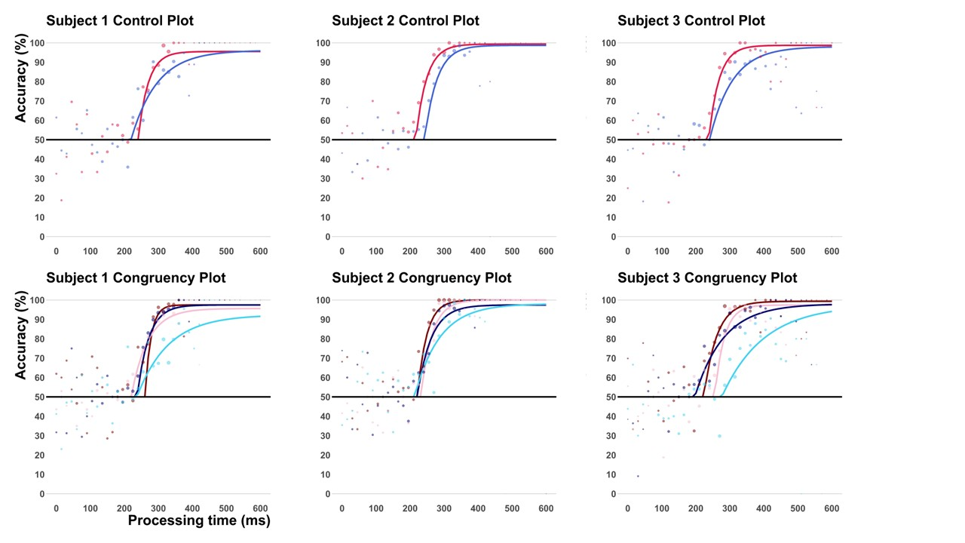
Subject Tachometric Curves
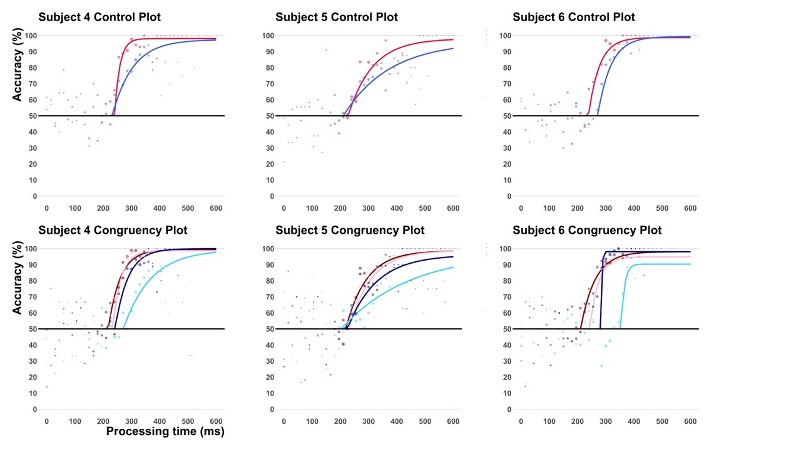
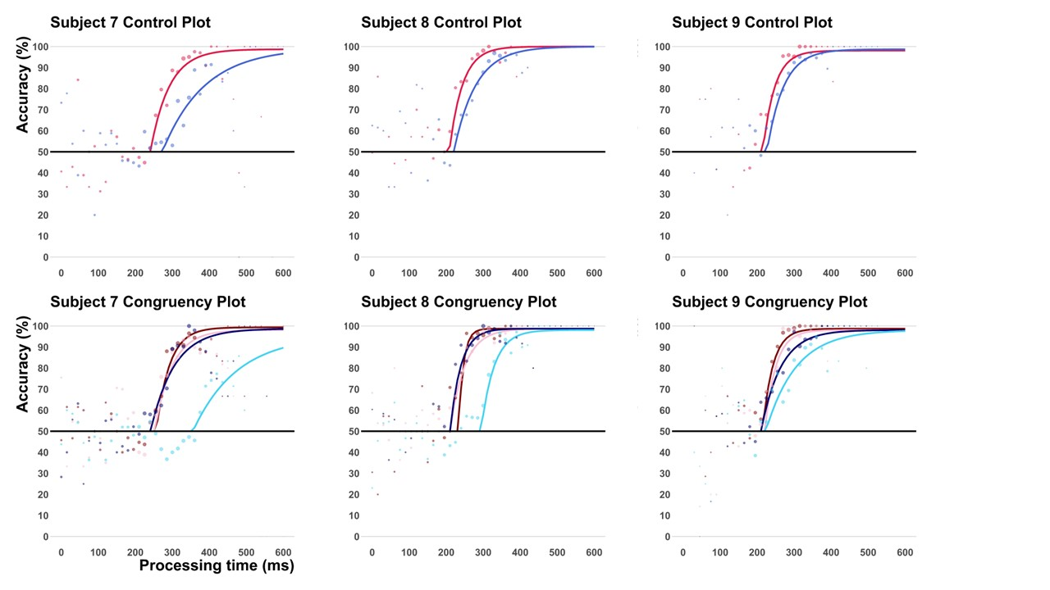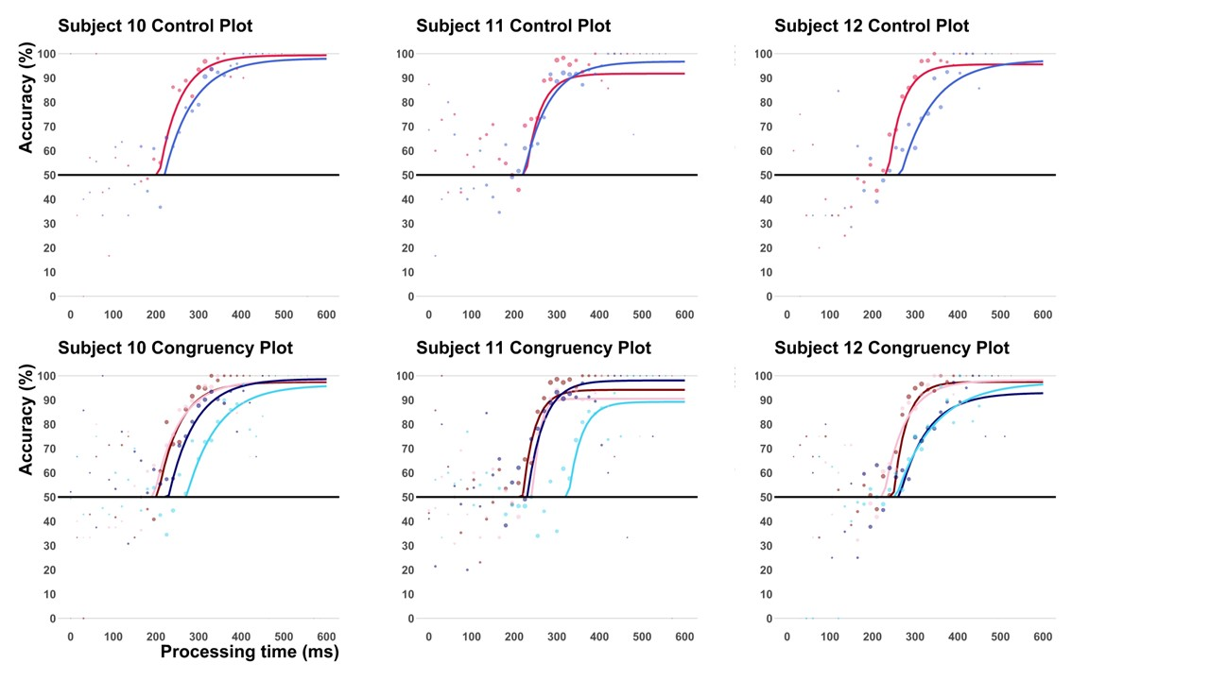

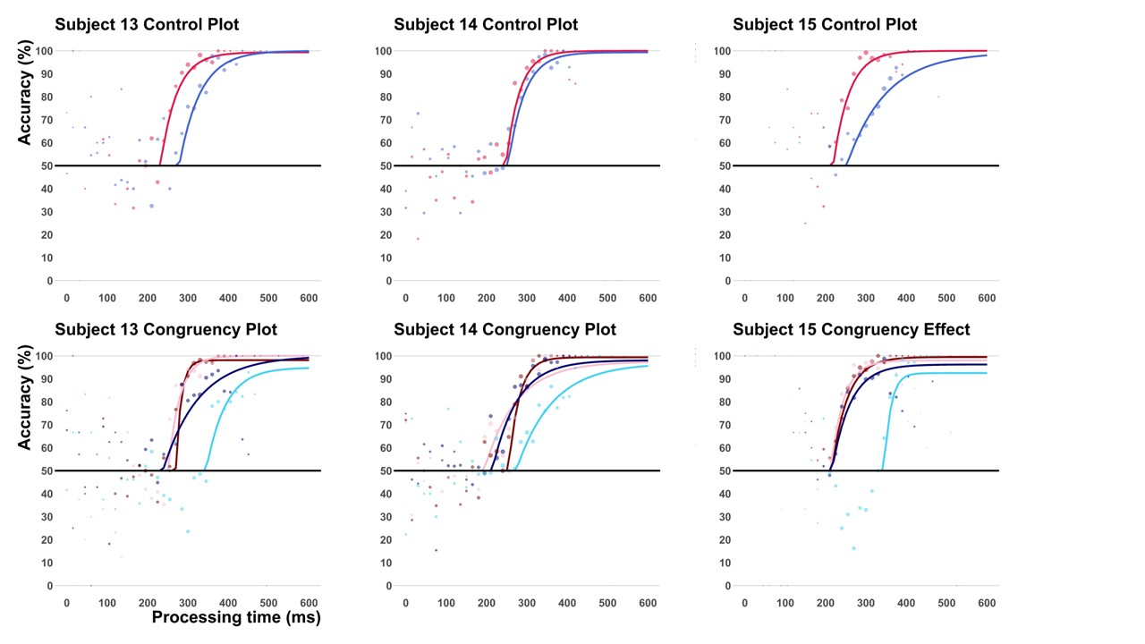

Parameter Comparison Plots

Across Conditions
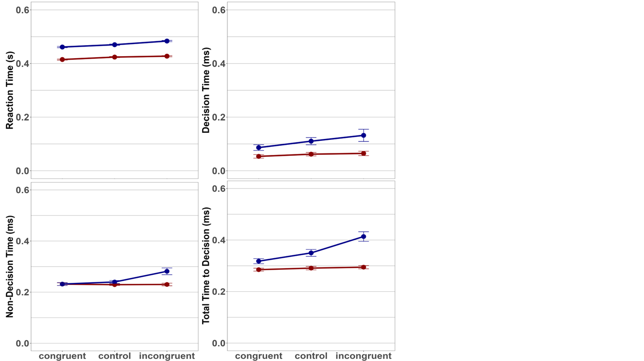

By subject
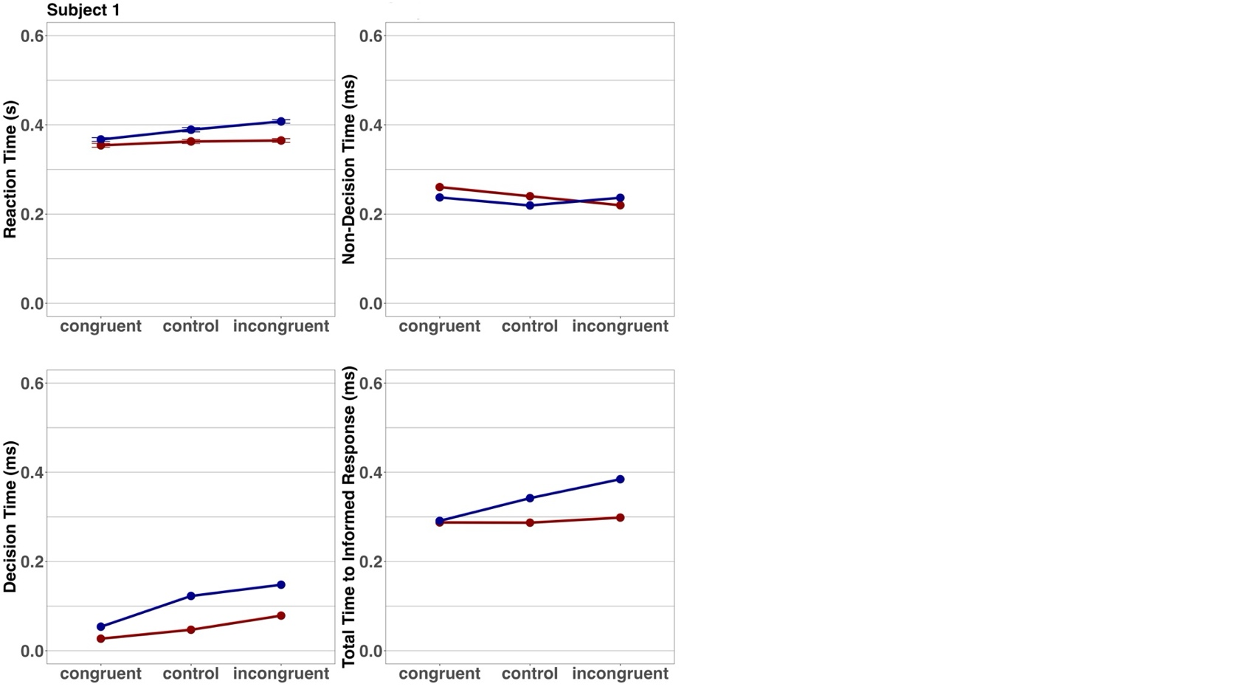
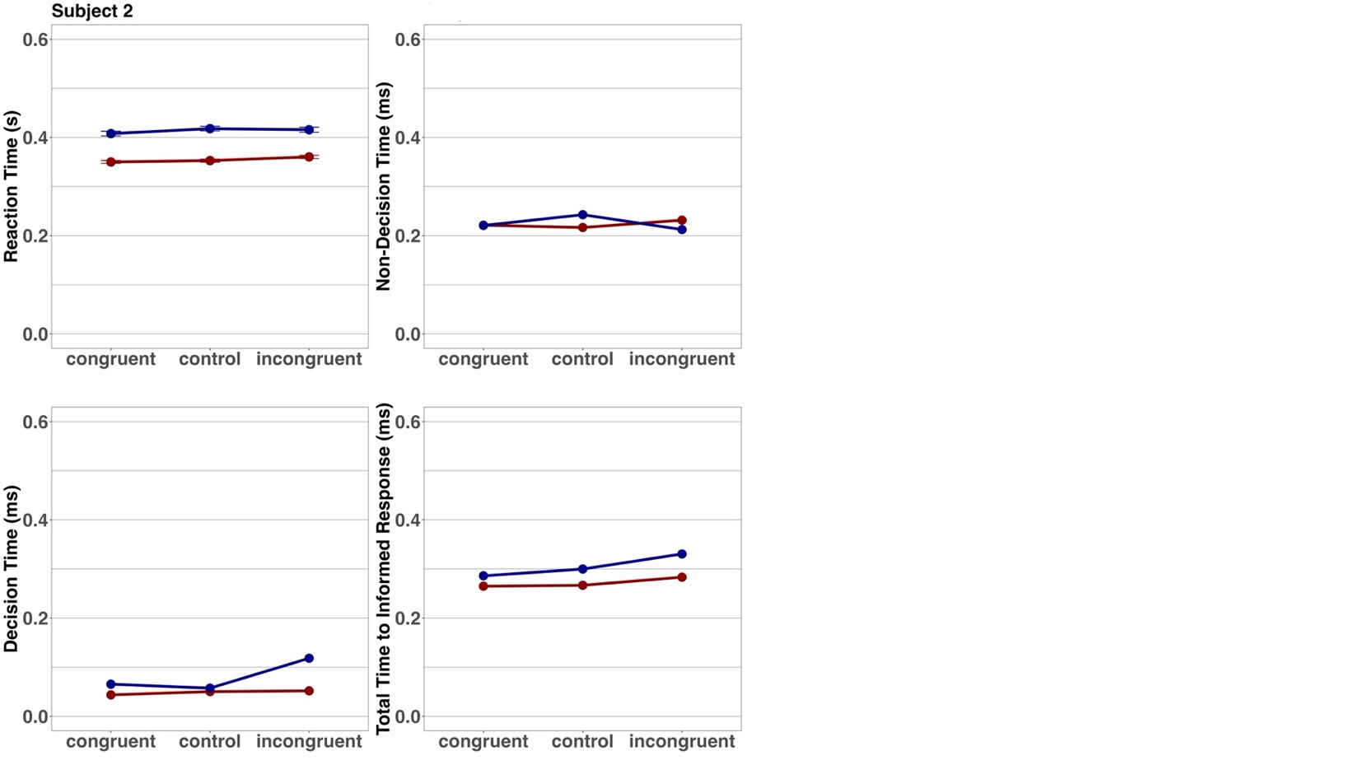
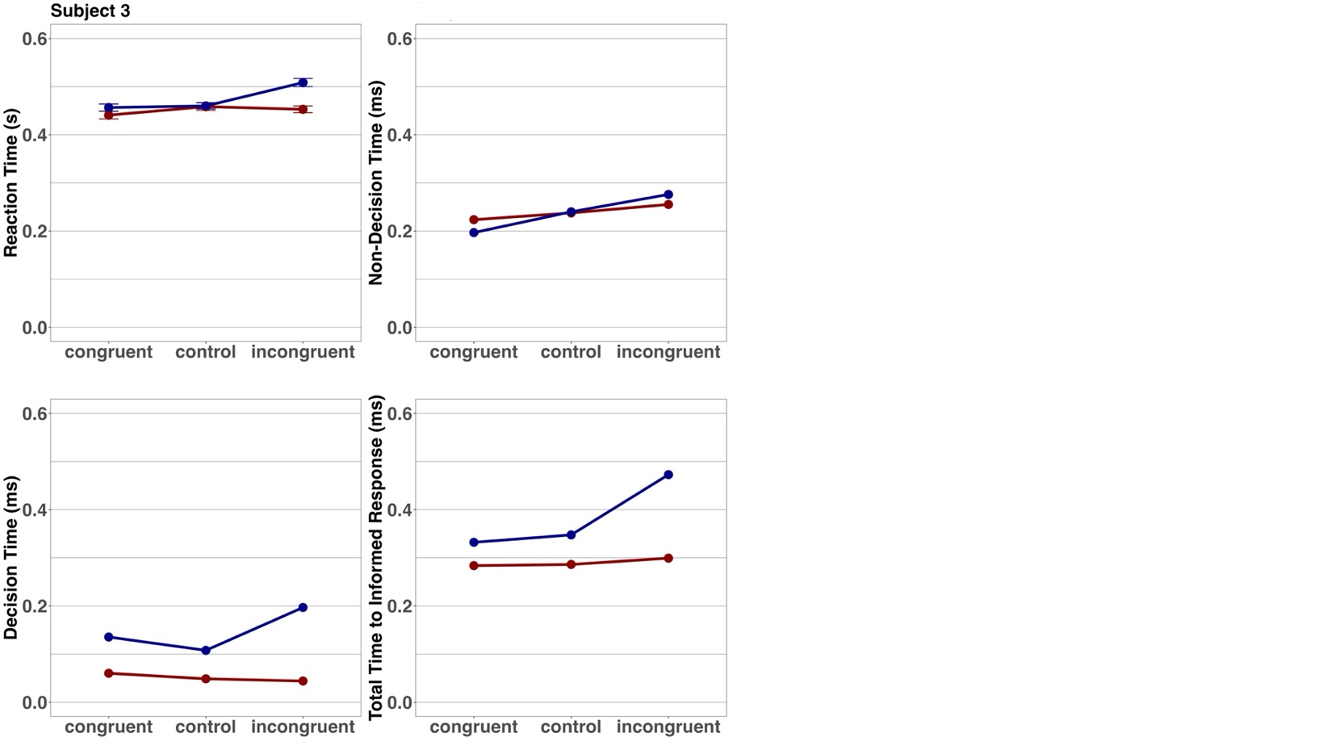

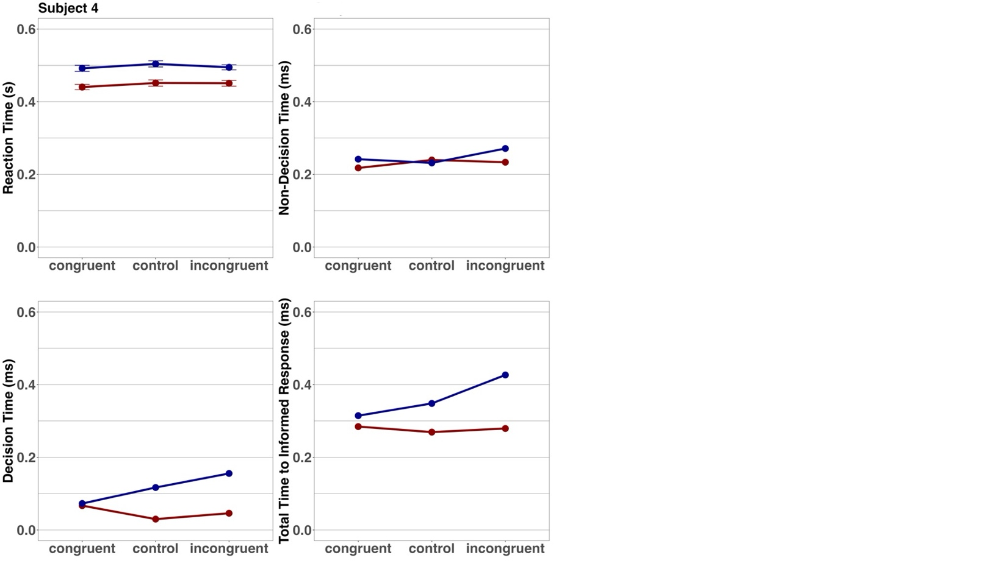
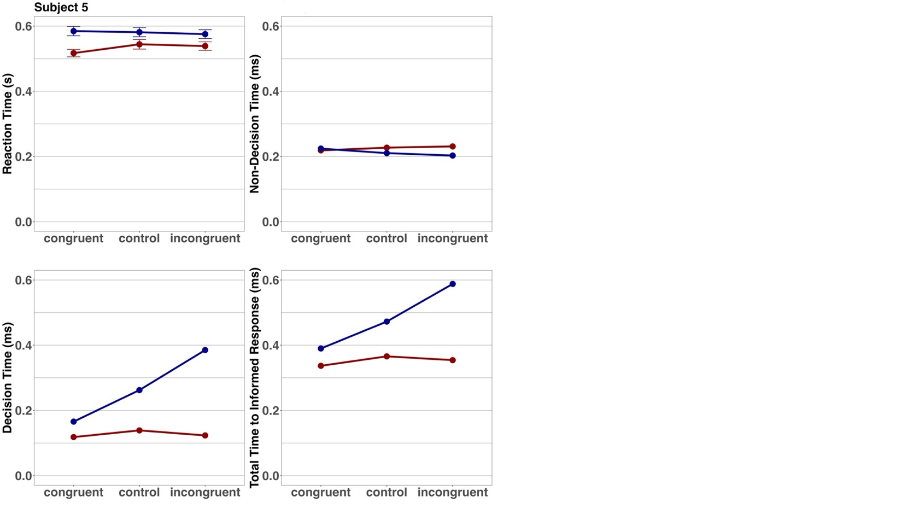
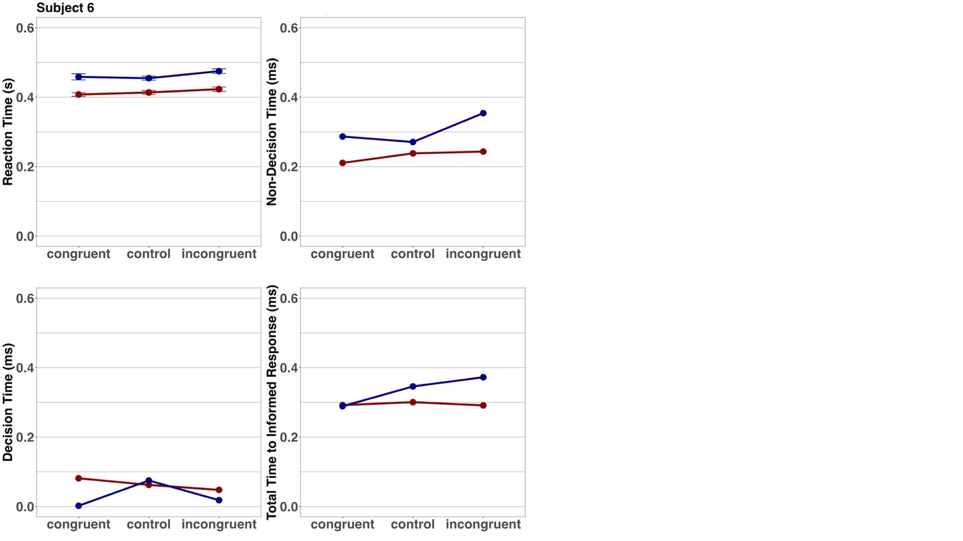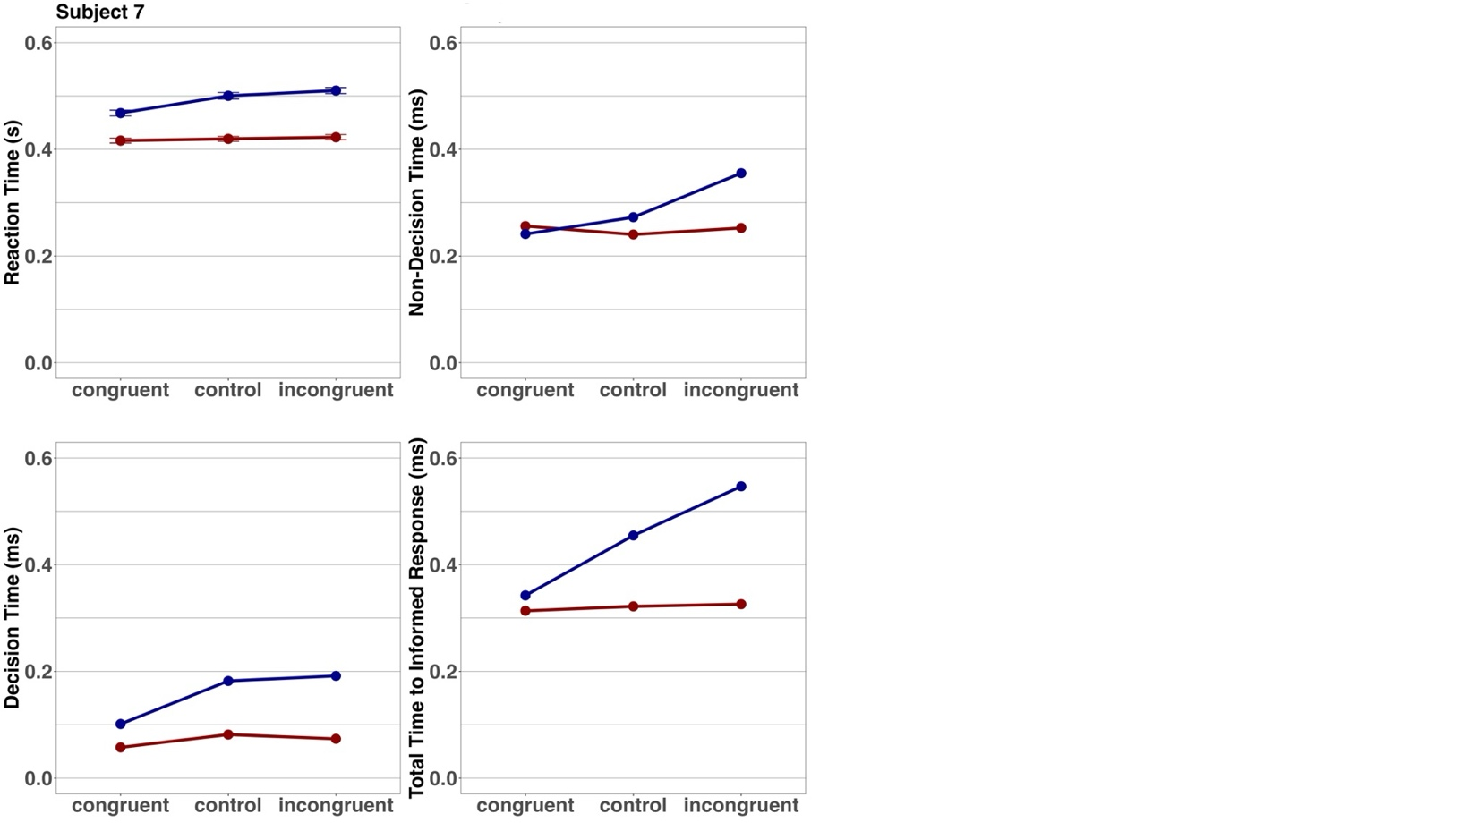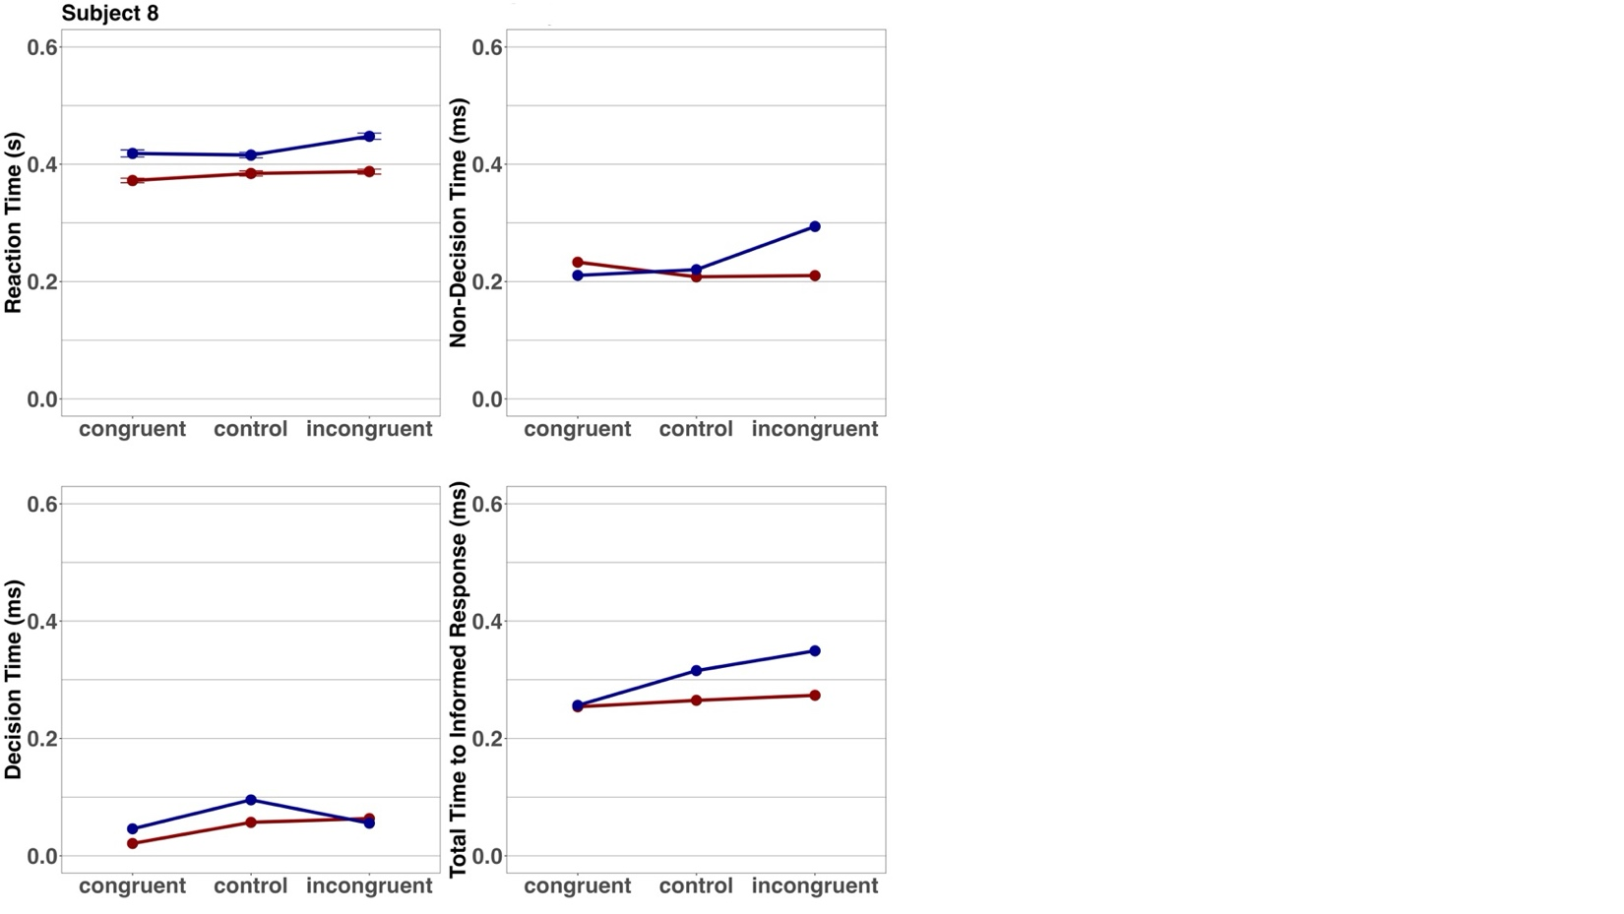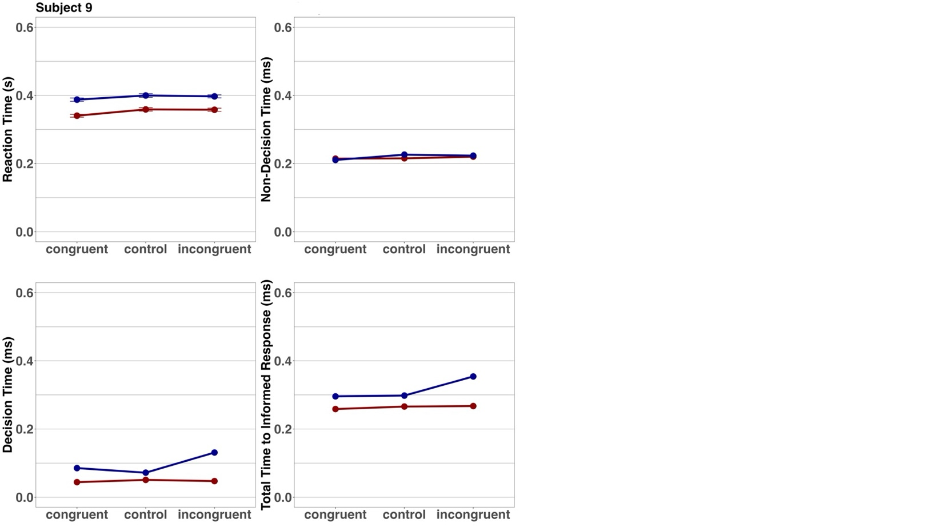
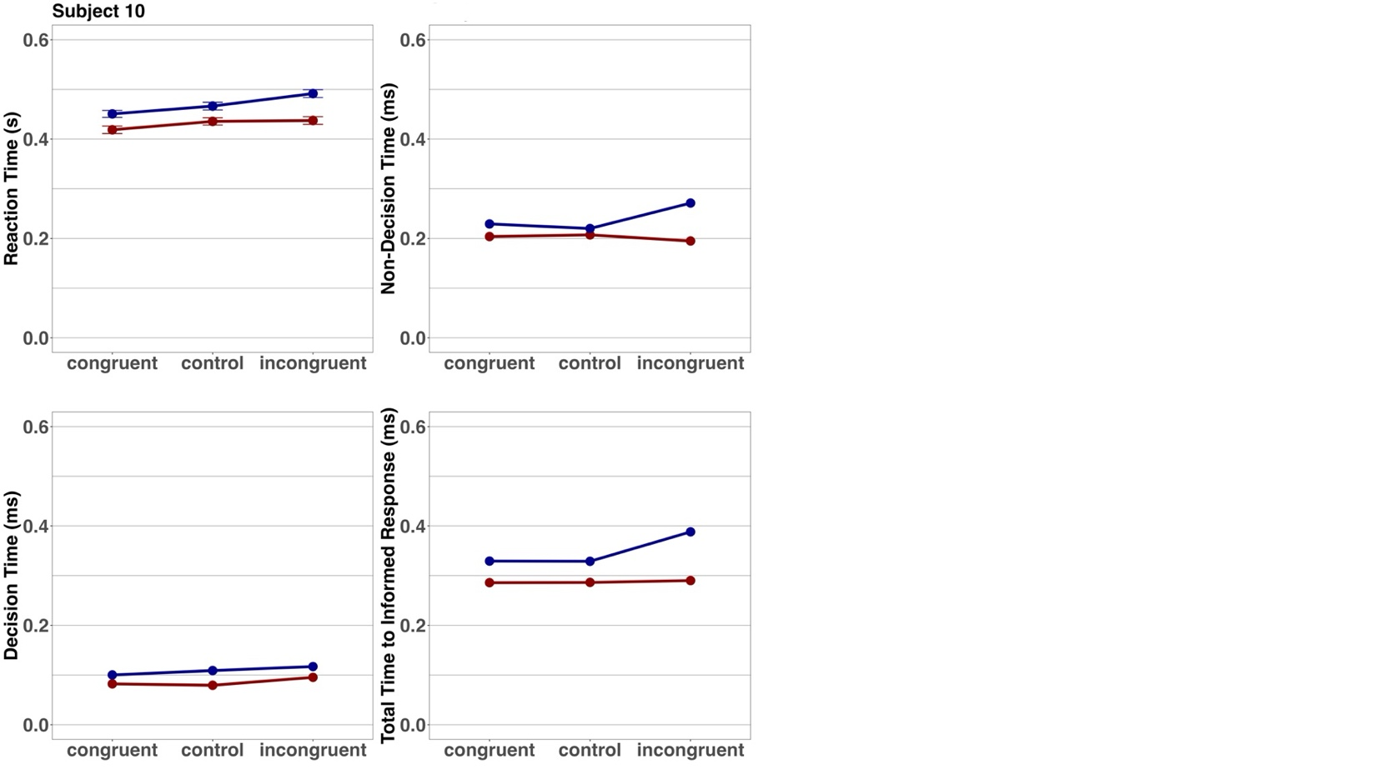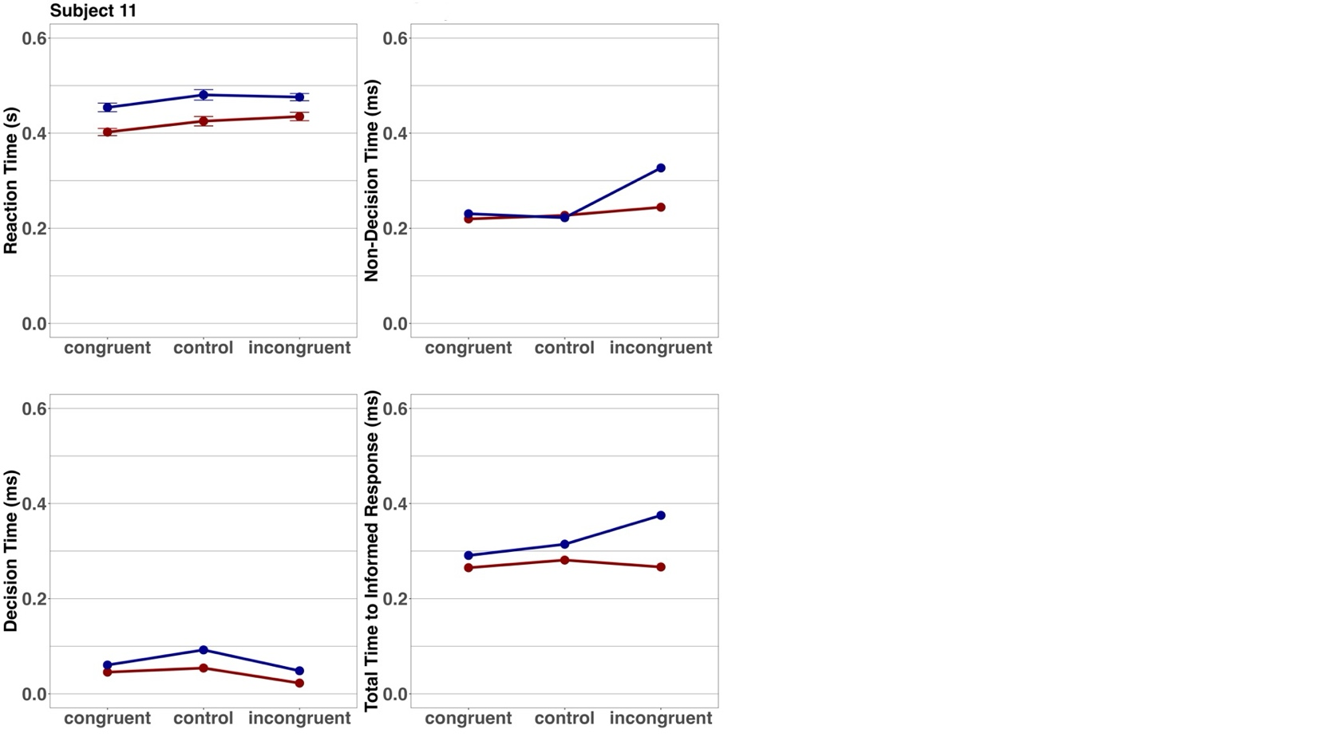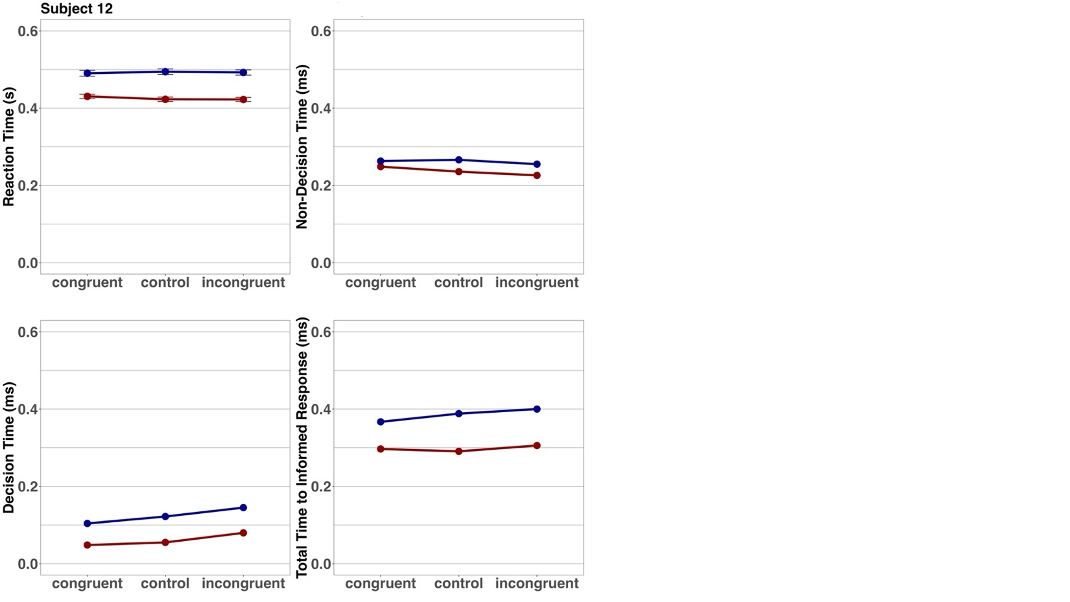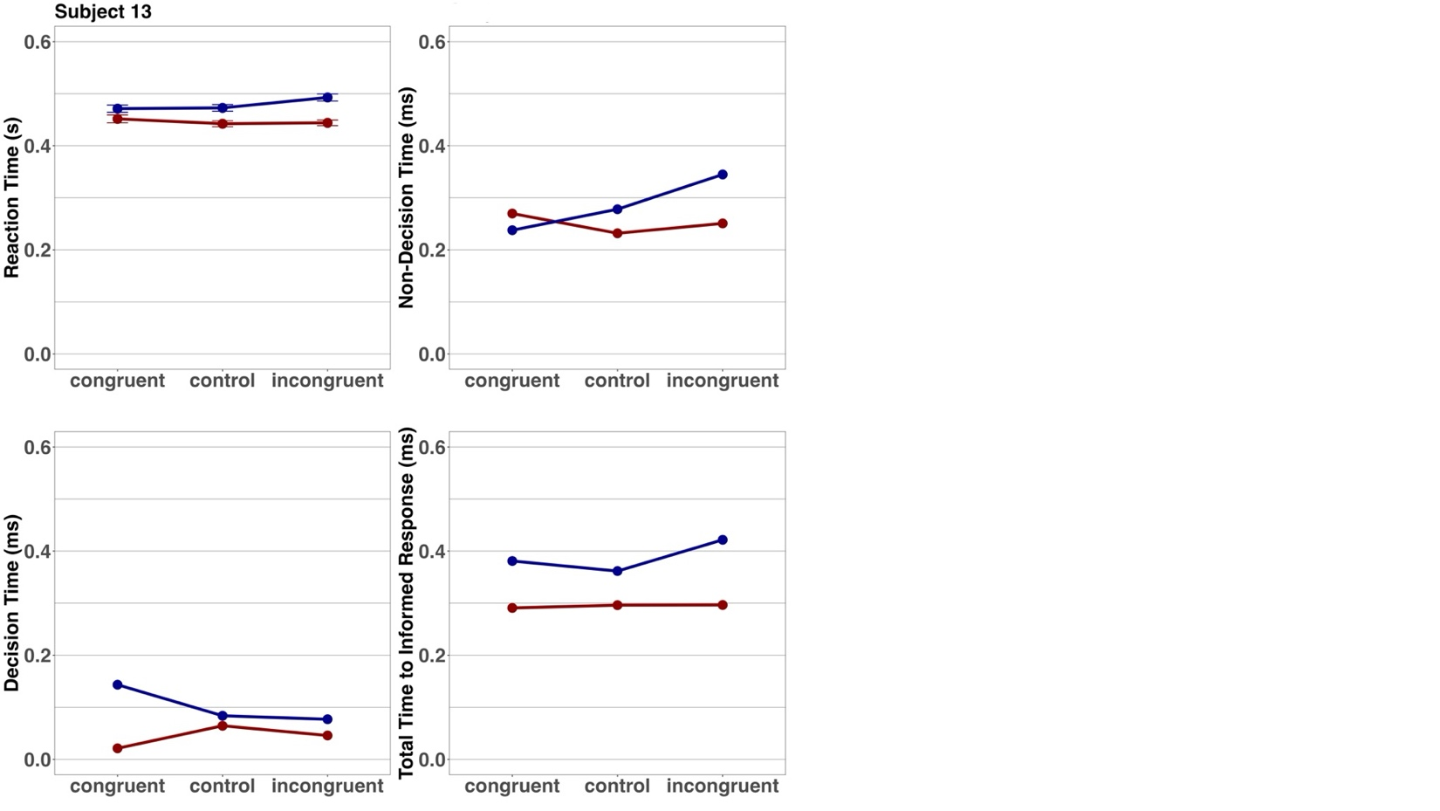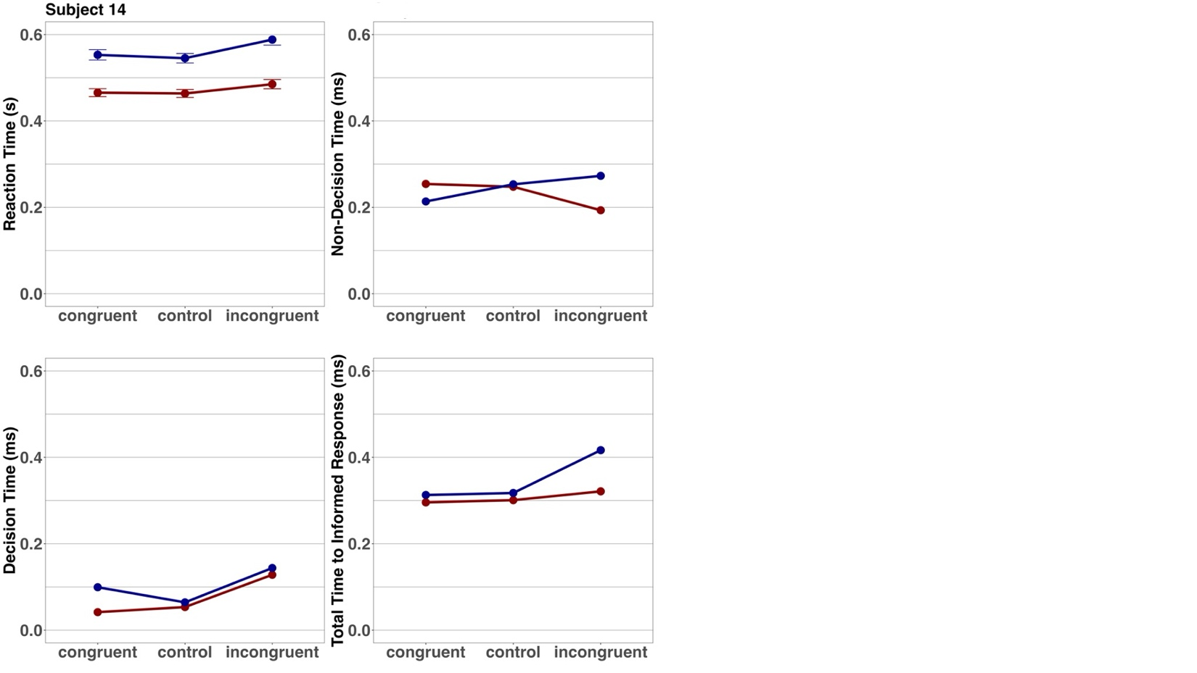

Line of Equality Plots
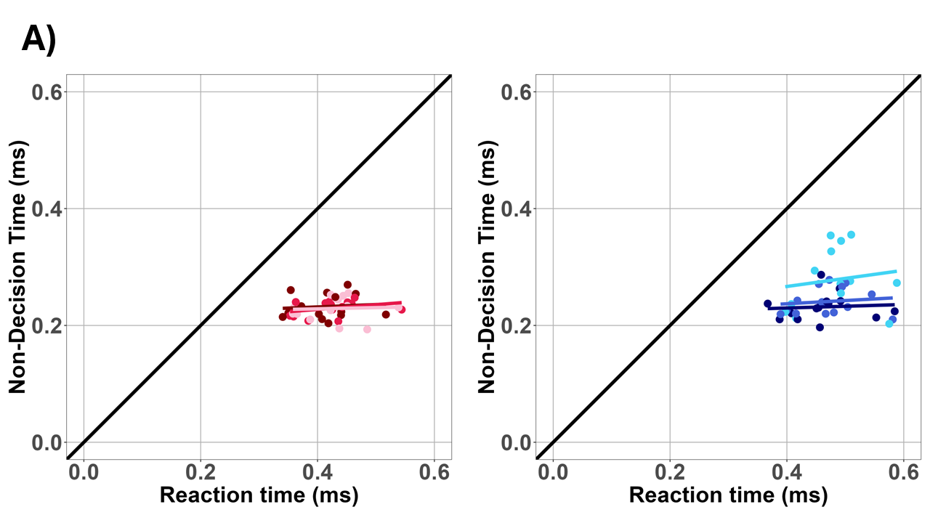

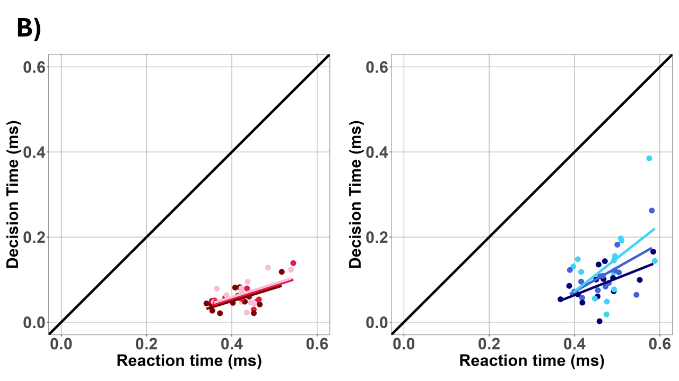
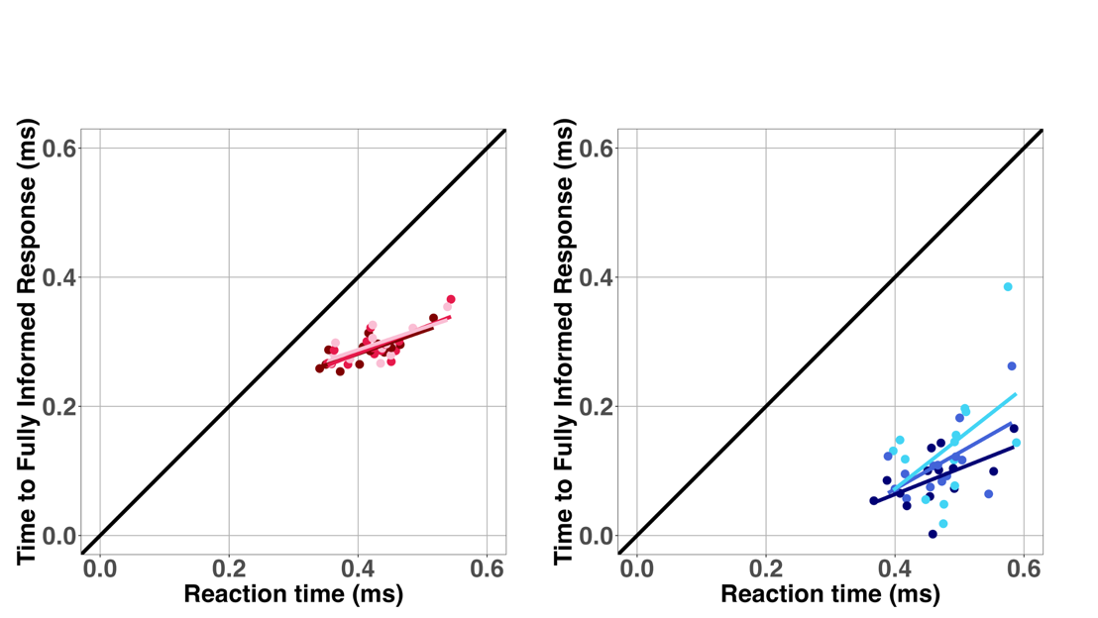

Bibliography

American Psychiatric Association. (2013). Diagnostic and Statistical Manual of Mental Disorders (5th ed.). American Psychiatric Association. doi-org.db29.linccweb.org/10.1176/ appi.books.9780890425596.dsm02
Baisa, A., Mevorach, C., & Shalev, L. (2021). Hierarchical Processing in ASD is Driven by Exaggerated Salience Effects, not Local Bias. Journal of Autism and Developmental Disorders, 51(2), 666–676. https://doi.org/10.1007/s10803-020-04578-1
Booth, R., Charlton, R., Hughes, C., & Happe, F. (2003). Disentangling weak coherence and executive dysfunction: Planning drawing in autism and attention-deficit/hyperactivity disorder. Philosophical Transactions of the Royal Society of London. Series B, Biological Sciences, 358, 387–392. https://doi.org/10.1098/rstb.2002.1204
Brederoo, S. G., Nieuwenstein, M. R., Lorist, M. M., & Cornelissen, F. W. (2017). Hemispheric specialization for global and local processing: A direct comparison of linguistic and non-linguistic stimuli. Brain and Cognition, 119, 10–16. https://doi.org/10.1016/j.bandc.2017.09.005
Byosiere, S.-E., Chouinard, P. A., Howell, T. J., & Bennett, P. C. (2018). What do dogs (Canis familiaris) see? A review of vision in dogs and implications for cognition research. Psychonomic Bulletin & Review, 25(5), 1798–1813. https://doi.org/10.3758/s13423-017-1404-7
Canals, J., Morales-Hidalgo, P., Voltas, N., & Hernández-Martínez, C. (2024). Prevalence of comorbidity of autism and ADHD and associated characteristics in school population: EPINED study. Autism Research: Official Journal of the International Society for Autism Research, 17(6), 1276–1286. https://doi.org/10.1002/aur.3146
Carther-Krone, T. A., & Marotta, J. J. (2022). The influence of magnocellular and parvocellular visual information on global processing in White and Asian populations. PLOS ONE, 17(7), e0270422. https://doi.org/10.1371/journal.pone.0270422
Chua, S. Y. P., Rentzelas, P., Frangou, P., Kourtzi, Z., Lintern, M., & Mavritsaki, E. (2022). Cultural differences in visual perceptual learning. International Journal of Psychology, 57(3), 377–386. https://doi.org/10.1002/ijop.12824
Colzato, L. S., Beest, I. van, van den Wildenberg, W. P. M., Scorolli, C., Dorchin, S., Meiran, N., Borghi, A. M., & Hommel, B. (2010). God: Do I have your attention? Cognition, 117(1), 87–94. https://doi.org/10.1016/j.cognition.2010.07.003
Deruelle, C., & Fagot, J. (1997). Hemispheric lateralisation and global precedence effects in the processing of visual stimuli by humans and baboons (Papio papio). Laterality, 2(3–4), 233–246. https://doi.org/10.1080/713754268
Dyer, A. G., Paulk, A. C., & Reser, D. H. (2010). Colour processing in complex environments: Insights from the visual system of bees. Proceedings of the Royal Society B: Biological Sciences, 278(1707), 952–959. https://doi.org/10.1098/rspb.2010.2412
Fagot, J., Tomonaga, M., & Deruelle, C. (2001). Processing of the Global and Local Dimensions of Visual Hierarchical Stimuli by Humans (Homo sapiens), Chimpanzees (Pan troglodytes), and Baboons (Papio papio). In T. Matsuzawa (Ed.), Primate Origins of Human Cognition and Behavior (pp. 87–103). Springer Japan. https://doi.org/10.1007/978-4-431-09423-4_4
Faraone, S. V., Banaschewski, T., Coghill, D., Zheng, Y., Biederman, J., Bellgrove, M. A., Newcorn, J. H., Gignac, M., Al Saud, N. M., Manor, I., Rohde, L. A., Yang, L., Cortese, S., Almagor, D., Stein, M. A., Albatti, T. H., Aljoudi, H. F., Alqahtani, M. M. J., Asherson, P., … Wang, Y. (2021). The World Federation of ADHD International Consensus Statement: 208 Evidence-based conclusions about the disorder. Neuroscience & Biobehavioral Reviews, 128, 789–818. https://doi.org/10.1016/j.neubiorev.2021.01.022
Feltner, K. A., & Kiorpes, L. (2010). Global visual processing in macaques studied using Kanizsa illusory shapes. Visual Neuroscience, 27(3–4), 131–138. https://doi.org/10.1017/S0952523810000088
Flevaris, A., Bentin, S., & Robertson, L. (2010). Local or Global?: Attentional Selection of Spatial Frequencies Binds Shapes to Hierarchical Levels. Psychological Science, 21, 424–431. https://doi.org/10.1177/0956797609359909
Flevaris, A. V., & Robertson, L. C. (2016). Spatial frequency selection and integration of global and local information in visual processing: A selective review and tribute to Shlomo Bentin. Neuropsychologia, 83, 192–200. https://doi.org/10.1016/j.neuropsychologia.2015.10.024
Frith, U. (1989). Autism: Explaining the enigma. British Journal of Developmental Psychology, 465–468.
Frith, U. (2003). Autism: Explaining the enigma, 2nd ed (pp. ix, 249). Blackwell Publishing.
Happé, F., & Frith, U. (2006). The Weak Coherence Account: Detail-focused Cognitive Style in Autism Spectrum Disorders. Journal of Autism and Developmental Disorders, 36(1), 5–25. https://doi.org/10.1007/s10803-005-0039-0
Hommel, B., & Colzato, L. S. (2010). Religion as a Control Guide: On the Impact of Religion on Cognition. Zygon®, 45(3), 596–604. https://doi.org/10.1111/j.1467-9744.2010.01116.x
Kalanthroff, E., Naparstek, S., & Henik, A. (2013). Spatial Processing in Adults With Attention Deficit Hyperactivity Disorder. Neuropsychology, 27. https://doi.org/10.1037/a0033655
Karalunas, S. L., Geurts, H. M., Konrad, K., Bender, S., & Nigg, J. T. (2014). Annual Research Review: Reaction time variability in ADHD and autism spectrum disorders: measurement and mechanisms of a proposed trans-diagnostic phenotype. Journal of Child Psychology and Psychiatry, 55(6), 685–710. https://doi.org/10.1111/jcpp.12217
Kimchi, R. (1992). Primacy of wholistic processing and global/local paradigm: A critical review. Psychological Bulletin, 112, 24–38. https://doi.org/10.1037/0033-2909.112.1.24
Kinchla, R. A., & Wolfe, J. M. (1979). The order of visual processing: “Top-down,” “bottom-up,” or “middle-out.” Perception & Psychophysics, 25(3), 225–231. https://doi.org/10.3758/BF03202991
Li, D., Li, T., Niu, Y., Xiang, J., Cao, R., Liu, B., Zhang, H., & Wang, B. (2019). Reduced hemispheric asymmetry of brain anatomical networks in attention deficit hyperactivity disorder. Brain Imaging and Behavior, 13(3), 669–684. https://doi.org/10.1007/s11682-018-9881-5
Lockyer, L., & Rutter, M. (1970). A five- to fifteen-year follow-up study of infantile psychosis. IV. Patterns of cognitive ability. The British Journal of Social and Clinical Psychology, 9(2), 152–163. https://doi.org/10.1111/j.2044-8260.1970.tb00654.x
Lomber, S. G. (2002). Learning to see the trees before the forest: Reversible deactivation of the superior colliculus during learning of local and global visual features. Proceedings of the National Academy of Sciences, 99(6), 4049–4054. https://doi.org/10.1073/pnas.062551899
Mongillo, P., Pitteri, E., Sambugaro, P., Carnier, P., & Marinelli, L. (2017). Global bias reliability in dogs (Canis familiaris). Animal Cognition, 20(2), 257–265. https://doi.org/10.1007/s10071-016-1044-8
Mottron, L., & Burack, J. A. (2001). Enhanced perceptual functioning in the development of autism. In The development of autism: Perspectives from theory and research (pp. 131–148). Lawrence Erlbaum Associates Publishers.
Mottron, L., Dawson, M., Soulières, I., Hubert, B., & Burack, J. (2006). Enhanced Perceptual Functioning in Autism: An Update, and Eight Principles of Autistic Perception. Journal of Autism and Developmental Disorders, 36(1), 27–43. https://doi.org/10.1007/s10803-005-0040-7
Müller-Oehring, E. M., Schulte, T., Raassi, C., Pfefferbaum, A., & Sullivan, E. V. (2007). Local–global interference is modulated by age, sex and anterior corpus callosum size. Brain Research, 1142, 189–205. https://doi.org/10.1016/j.brainres.2007.01.062
Navon, D. (1977). Forest before trees: The precedence of global features in visual perception. Cognitive Psychology, 9(3), 353–383. https://doi.org/10.1016/0010-0285(77)90012-3
Navon, D. (1981). The forest revisited: More on global precedence. Psychological Research, 43(1), 1–32. https://doi.org/10.1007/BF00309635
Neufeld, J., Hagström, A., Van’t Westeinde, A., Lundin, K., Cauvet, É., Willfors, C., Isaksson, J., Lichtenstein, P., & Bölte, S. (2020). Global and local visual processing in autism – a co-twin-control study. Journal of Child Psychology and Psychiatry, 61(4), 470–479. https://doi.org/10.1111/jcpp.13120
Pletzer, B. (2014). Sex-specific strategy use and global-local processing: A perspective toward integrating sex differences in cognition. Frontiers in Neuroscience, 8, 425. https://doi.org/10.3389/fnins.2014.00425
Ratcliff, R. (1978). A theory of memory retrieval. Psychological Review, 85, 59–108. https://doi.org/10.1037/0033-295X.85.2.59
Razumnikova, O., & Volf, N. (2010). Selection of visual hierarchical stimuli between global and local aspects in men and women. Fiziologiia Cheloveka, 37, 14–19.
Rong, Y., Yang, C.-J., Jin, Y., & Wang, Y. (2021). Prevalence of attention-deficit/hyperactivity disorder in individuals with autism spectrum disorder: A meta-analysis. Research in Autism Spectrum Disorders, 83, 101759. https://doi.org/10.1016/j.rasd.2021.101759
Sandson, T., Bachna, K., & Morin, M. (2000). Right Hemisphere Dysfunction in ADHD: Visual Hemispatial Inattention and Clinical Subtype. Journal of Learning Disabilities, 33, 83–90. https://doi.org/10.1177/002221940003300111
Santacà, M. (2024). Some like it “local”: A review of hierarchical processing in non-human animals. Learning & Behavior, 52(2), 143–161. https://doi.org/10.3758/s13420-023-00605-0
Scailquin, R. B., Jean-Christophe. (2000). The Fate of Global Precedence With Age. Experimental Aging Research, 26(4), 285–314. https://doi.org/10.1080/036107300750015705
Seernani, D., Ioannou, C., Damania, K., Spindler, K., Hill, H., Foulsham, T., Smyrnis, N., Bender, S., Fleischhaker, C., Biscaldi, M., Ebner-Priemer, U., & Klein, C. (2020). Studying global processing in autism and attention-deficit/hyperactivity disorder with gaze movements: The example of a copying task. PLOS ONE, 15(6), e0224186. https://doi.org/10.1371/journal.pone.0224186
Shah, A., & Frith, U. (1993). Why Do Autistic Individuals Show Superior Performance on the Block Design Task? Journal of Child Psychology and Psychiatry, 34(8), 1351–1364. https://doi.org/10.1111/j.1469-7610.1993.tb02095.x
Song, Y., & Hakoda, Y. (2015). Lack of global precedence and global-to-local interference without local processing deficit: A robust finding in children with attention-deficit/hyperactivity disorder under different visual angles of the Navon task. Neuropsychology, 29(6), 888–894. https://doi.org/10.1037/neu0000213
Stanford, T. R., Shankar, S., Massoglia, D. P., Costello, M. G., & Salinas, E. (2010). Perceptual decision making in less than 30 milliseconds. Nature Neuroscience, 13(3), Article 3. https://doi.org/10.1038/nn.2485
Staudinger, M. R., Fink, G. R., Mackay, C. E., & Lux, S. (2011). Gestalt perception and the decline of global precedence in older subjects. Cortex, 47(7), 854–862. https://doi.org/10.1016/j.cortex.2010.08.001
Tymchuk, A. J., Simmons, J. Q., & Neafsey, S. (1977). Intellectual characteristics of adolescent childhood psychotics with high verbal ability. Journal of Mental Deficiency Research, 21(2), 133–138.
Van der Hallen, R., Evers, K., Brewaeys, K., Van den Noortgate, W., & Wagemans, J. (2015). Global processing takes time: A meta-analysis on local–global visual processing in ASD. Psychological Bulletin, 141(3), 549–573. https://doi.org/10.1037/bul0000004
Van der Hallen, R., Vanmarcke, S., Noens, I., & Wagemans, J. (2017). Hierarchical Letters in ASD: High Stimulus Variability Under Different Attentional Modes. Journal of Autism and Developmental Disorders, 47(6), 1854–1865. https://doi.org/10.1007/s10803-017-3108-2
Van Kleeck, M. H. (1989). Hemispheric differences in global versus local processing of hierarchical visual stimuli by normal subjects: New data and a meta-analysis of previous studies. Neuropsychologia, 27(9), 1165–1178. https://doi.org/10.1016/0028-3932(89)90099-7
Voyer, D., & MacPherson, B. R. (2020). Sex differences in curve tracing. Canadian Journal of Experimental Psychology / Revue Canadienne de Psychologie Expérimentale, 74(4), 330–345. https://doi.org/10.1037/cep0000205
Wagemans, J., Feldman, J., Gepshtein, S., Kimchi, R., Pomerantz, J. R., van der Helm, P. A., & van Leeuwen, C. (2012). A Century of Gestalt Psychology in Visual Perception II. Conceptual and Theoretical Foundations. Psychological Bulletin, 138(6), 1218–1252. https://doi.org/10.1037/a0029334
Watanabe, A., Fujimoto, M., Hirai, K., & Ushitani, T. (2019). Pigeons discriminate shapes based on topological features. Vision Research, 158, 120–125. https://doi.org/10.1016/j.visres.2019.02.012
Yovel, G., Yovel, I., & Levy, J. (2001). Hemispheric asymmetries for global and local visual perception: Effects of stimulus and task factors. Journal of Experimental Psychology: Human Perception and Performance, 27(6), 1369–1385. https://doi.org/10.1037/0096-1523.27.6.1369
Yuan, J., Pan, H., Sun, Y., Wang, Y., & Jia, J. (2024). Neural responses to global and local visual information processing provide neural signatures of ADHD symptoms. https://doi.org/10.21203/rs.3.rs-4212513/v1

